THEMIS: A Mutually Verifiable Billing System

for the Cloud Computing Environment

**Abstract**

Cloud computing is an important transition that makes change in service oriented computing technology. With the widespread adoption of cloud computing, the ability to record and account for the usage of cloud resources in a credible and verifiable way has become critical for cloud service providers and users alike. The success of such a billing system depends on several factors: the billing transactions must have integrity and no repudiation capabilities; the billing transactions must be non obstructive and have a minimal computation cost; and the service level agreement (SLA) monitoring should be provided in a trusted manner. Existing billing systems are limited in terms of security capabilities or computational overhead. This project proposes a secure and non obstructive billing system called THEMIS as a remedy for these limitations. The system uses a novel concept of a cloud notary authority for the supervision of billing. The cloud notary authority generates mutually verifiable binding information that can be used to resolve future disputes between a user and a cloud service provider in a computationally efficient way. Even administrator of a cloud system cannot modify or falsify the data.

**TABLE OF CONTENTS**

|  |  |  |
| --- | --- | --- |
| **CHAPTER NO.** | **TITLE** | **PAGE NO.** |
|  | **ABSTRACT**  **LIST OF FIGURES**  **LIST OF SYMBOLS**  **LIST OF ABBREVIATIONS**  **LIST OF TABLES** | i  vii  ix  xiii |
| 1. | **CHAPTER 1 : INTRODUCTION**   * 1. GENERAL   2. OBJECTIVE   3. EXISTING SYSTEM   1.3.1.EXISTING DISADVANTAGE  1.3.2.LITERATURE SURVEY  1.4 PROPOSED SYSTEM  1.4.1 PROPOSED SYSTEM ADVANTAGES |  |
| 2. | **CHAPTER 2**  2.1 GENERAL  2.2 PROBLEM DEFINATION  2.3 METHODOLOGIES  2.3.1MODULES NAME  2.3.2 MODULES EXPLANATION  2.3.3 MODULE DIAGRAM  2.3.4 GIVEN INPUTAND EXPECTED OUTPUT  2.4 TECHNIQUE OR ALGORITHM |  |
| 3. | **CHAPTER 3 : REQUIREMENTS ENGINEERING**  3.1 General  3.2 Hardware REQUIREMENTS  3.3 Software REQUIREMENTS  3.4 Functional Specification  3.5 Non-Functional Specification |  |
| 4. | **CHAPTER 4 : SYSTEM DESIGN**  **4.1 general**  4.1.1 activity diagram  4.1.2 USE CASE DIAGRAM  4.1.3 DATA FLOW DIAGRAM  4.1.4 SEQUENCE DIAGRAM  4.1.5 COLLABORATION DIAGRAM  4.1.6 CLASS DIAGRAM  4.1.7 SYSTEM ARCHITECTURE  4.1.8 OBJECT DIAGRAM  4.1.9 STATE DIAGRAM  4.1.10 COMPONENT DIAGRAM  4.1.11 E-R DIAGRAM |  |
| 5. | **CHAPTER 5 :SOFTWARE SPECIFICATION**  5.1 general  5.2 features of java  5.2.1 the java framework  5.2.2 objective of java |  |
| 6. | **CHAPTER 6 : IMPLEMENTATION**  6.1 GENERAL  6.2 IMPLEMENTATION  6.3 DATA BASE TABLE STRUCTURE |  |

|  |  |  |
| --- | --- | --- |
| 7. | **CHAPTER 7 : SNAPSHOTS**  7.1 GENERAL  7.2 VARIOUS SNAPSHOTS |  |
| 8. | **CHAPTER 8 :**  **APPLICATIONS AND FUTURE ENHANCEMENT**  8.1 GENERAL  8.2 APPLICATIONS  8.3 FUTURE ENHANCEMENTS |  |
| **9** | **CHAPTER 9 :**  9.1CONCLUSION  9.2 REFERENCES |  |

**LIST OF FIGURES**

|  |  |  |
| --- | --- | --- |
| **FIGURE NO** | **NAME OF THE FIGURE** | **PAGE NO.** |
| 2.3.1 | Module Diagram |  |
| 4.1.1 | Activity Diagram |  |
| 4.1.2 | Use case Diagram |  |
| 4.1.3 | Data flow diagram |  |
| 4.1.4 | Sequence diagram |  |
| 4.1.5 | Collaboration diagram |  |
| 4.1.6 | Class diagram |  |
| 4.1.7 | Architecture Diagram |  |
| 4.1.8 | Object Diagram |  |
| 4.1.9 | State Diagram |  |
| 4.1.10 | Component Diagram |  |
| 4.1.11 | E-R Diagram |  |

**LIST OF SYSMBOLS**

|  |  |  |  |
| --- | --- | --- | --- |
| **S.NO** | **NOTATION**  **NAME** | **NOTATION** | **DESCRIPTION** |
| 1. | Class | *Class Name*  *-attribute*  *-attribute*  *+operation*  *+operation*  *+operation*  *+ Public*  *-private*  *# protected* | Represents a collection of similar entities grouped together. |
| 2. | Association | name  Class B  Class A  Class A  Class B | Associations represent static relationships between classes. Roles represent the way the two classes see each other. |
| 3. | Actor | Class A  Class A  Class B  Class B | It aggregates several classes into single classes. |
| 5. | Aggregation | Interaction between the system and external environment |

|  |  |  |  |
| --- | --- | --- | --- |
| 5. | Relation  (uses) | Uses | Used for additional process communication. |
| 6. | Relation  (extends) | extends | Extends relationship is used when one use case is similar to another use case but does a bit more. |
| 7. | Communication |  | Communication between various use cases. |
| 8. | State | State | State of the process. |
| 9. | Initial State |  | Initial state of the object |
| 10. | Final state |  | F final state of the object |
| 11. | Control flow |  | Represents various control flow between the states. |
| 12. | Decision box |  | Represents decision making process from a constraint |
| 13. | Use case |  | Interaction between the system and external environment. |

|  |  |  |  |
| --- | --- | --- | --- |
| 14. | Component |  | Represents a physical module which is a collection of components. |
| 15. | Node |  | Represents physical modules which are a collection of components. |
| 16. | Data Process/State |  | A circle in DFD represents a state or process which has been triggered due to some event or action. |
| 17. | External entity |  | Represents external entities such as keyboard, sensors, etc. |
| 18. | Transition |  | Represents communication that occurs between processes. |
| 19. | Object Lifeline |  | Represents the vertical dimensions that the object communications. |
| 20. | Message | Message | Represents the message exchanged. |

**LIST OF ABBREVATION**

|  |  |  |
| --- | --- | --- |
| **S.NO** | **ABBREVATION** | **EXPANSION** |
| 1**.** | CSP | Cloud Service Provider |
| 2. | CNA | Cloud Notary Authority |
| 3. | SLA | Service Level Agreement |
| 4. |  |  |
| 5. |  |  |
| 6. |  |  |
| 7. | JDK | Java Development Kit |
| 8. | JVM | Java Virtual Machine |
| 9. | SQL | Structured Query Language |

**CHAPTER 1**

**INTRODUCTION**

**1.1. GENERAL**

Cloud computing is an important transition that makes change in service oriented computing technology. Cloud service provider follows pay-as-you-go pricing approach which means consumer uses as many resources as he need and billed by the provider based on the resource consumed. CSP give a quality of service in the form of a service level agreement. For transparent billing, each billing transaction should be protected against forgery and false modifications. Although CSPs provide service billing records, they cannot provide trustworthiness. It is due to user or CSP can modify the billing records. In this case even a third party cannot confirm that the user’s record is correct or CSPs record is correct. To overcome these limitations we introduced a secure billing system called THEMIS. For secure billing system THEMIS introduces a concept of cloud notary authority (CNA). CNA generates mutually verifiable binding information that can be used to resolve future disputes between user and CSP. This project will produce the secure billing through monitoring the service level agreement (SLA) by using the SMon module. CNA can get a service logs from SMon and stored it in a local repository for further reference. Even administrator of a cloud system cannot modify or falsify the data.

**1.2. OBJECTIVE**

Scope of the project is to provide a high securable and non obstructive billing system. Central Nodal Authority (CNA) generates the bill with binding information. The process, which involves a generation of mutually verifiable binding information among all the involved entities on the basis of a one-way hash chain, is computationally efficient for a thin client and the CSP. So even administrator of a cloud system cannot modify or falsify the data.

**1.3. EXISTING SYSTEM**

For the billing transaction existing system used public key infrastructure (PKI)-based digital signature into each billing transaction to prevent corruption. Several studies have addressed this issue by deploying a PKI-based digital signature mechanism in an underlying security layer; however, they were handicapped by computational overhead due to the extreme complexity of the PKI operations. In spite of the consensus that PKI-based billing systems offer a high level of security through two security functions (excluding trustworthy SLA monitoring),the security comes at the price of extremely complex PKI operations. Consequently, when a PKI-based billing system is used in a cloud computing environment, the high computational complexity causes high deployment costs and a high operational overhead because the PKI operations must be performed by the user and the CSP. The CSP may deliberately or unintentionally generate incorrect monitoring records, resulting in incorrect bills. To provide an SLA monitoring mechanism, several studies have made great efforts to design solutions that meet various requirements, including scalability with distributed resource monitoring, dataflow monitoring, and predictions of SLA violations, rather than addressing security concerns such as the integrity and trustworthiness of the monitoring mechanism. Thus, they are not fully supportive of the security issues.

**1.3.1. LITERATURE SURVEY**

**1.3.1.1 Above the clouds: A Berkeley view of cloud computing**

**Author:** M. Armbrust and A. E. Fox

**Year:** 2009

**Description:**

Cloud Computing, the long-held dream of computing as a utility, has the potential to transform a large part of the IT industry, making software even more attractive as a service and shaping the way IT hardware is designed and purchased. Developers with innovative ideas for new Internet services no longer require the large capital outlays in hardware to deploy their service or the human expense to operate it. They need not be concerned about over provisioning for a service whose popularity does not meet their predictions, thus wasting costly resources, or under provisioning for one that becomes wildly popular, thus missing potential customers and revenue. Moreover, companies with large batch-oriented tasks can get results as quickly as their programs can scale, since using 1000 servers for one hour costs no more than using one server for 1000 hours. This elasticity of resources, without paying a premium for large scale, is unprecedented in the history of IT. Cloud Computing refers to both the applications delivered as services over the Internet and the hardware and systems software in the datacenters that provide those services. The services themselves have long been referred to as Software as a Service (SaaS). The datacenter hardware and software is what we will call a Cloud. When a Cloud is made available in a pay-as-you-go manner to the general public, we call it a Public Cloud; the service being sold is Utility Computing. We use the term Private Cloud to refer to internal datacenters of a business or other organization, not made available to the general public. Thus, Cloud Computing is the sum of SaaS and Utility Computing, but does not include Private Clouds. People can be users or providers of SaaS, or users or providers of Utility Computing. We focus on SaaS Providers (Cloud Users) and Cloud Providers, which have received less attention than SaaS Users.

**1.3.1.2 Towards trusted cloud computing**

**Author:** N. Santos, K. P. Gummadi, and R. Rodrigues

**Year:** 2009

**Description:**

Cloud computing infrastructures enable companies to cut costs by outsourcing computations on-demand. However, clients of cloud computing services currently have no means of verifying the confidentiality and integrity of their data and computation. To address this problem we propose the design of a trusted cloud computing platform (TCCP). TCCP enables Infrastructure as a Service (IaaS) providers such as Amazon EC2 to provide a closed box execution environment that guarantees confidential execution of guest virtual machines. Moreover, it allows users to attest to the IaaS provider and determine whether or not the service is secure before they launch their virtual machines.

**1.3.1.3 Tamper detection in audit logs**

**Author:** R. T. Snodgrass, S. S. Yao, and C. Collberg

**Year:** 2004

**Description:**

Audit logs are considered good practice for business systems, and are required by federal regulations for secure systems, drug approval data, medical information disclosure, financial records, and electronic voting. Given the central role of audit logs, it is critical that they are correct and inalterable. It is not sufficient to say, \our data is correct, because we store all interactions in a separate audit log."The integrity of the audit log itself must also be guaranteed. This paper proposes mechanisms within a database management system (DBMS), based on cryptographically strong one-way hash functions, that prevent an intruder, including an auditor or an employee or even an unknown bug within the DBMS itself, from silently corrupting the audit log. We propose that the DBMS store additional information in the database to enable a separate audit log validate to examine the database along with this extra information and state conclusively whether the audit log has been compromised. We show with an implementation on a high-performance storage engine that the overhead for auditing is low and that the validate can efficiently and correctly determine if the audit log has been compromised.

**1.3.1.4 Apel: An implementation of grid accounting using r-gma**

**Author:** L. C. M. C. Rob Byrom, Roney Cordenonsib

**Year:** 2005

**Description:**

This article describes the implementation of an accounting tool in the LHC Computing Grid (LCG): a distributed computing grid project consisting of over 100 resource centers and more than 10,000 CPUs. APEL (Accounting Processor for Event Logs) parses batch, system and gatekeeper logs generated by a site and builds accounting records, which provide a summary of the resources consumed based on attributes such as CPU time, Wall Clock Time, Memory and grid user DN. The accounting data is published into the R-GMA information and monitoring system, and archived for processing by a graphical front-end utilized by the accounting web tool.

**1.3.1.5 Condor-g: A computation management agent for multi-institutional grids**

**Author:** Frey, Tannenbaum, Livny, Foster, and Tuecke

**Year:** 2002

**Description:**

In recent years, there has been a dramatic increase in the amount of available computing and storage resources, yet few have been able to exploit these resources in an aggregated form. We present the Condor-G system, which leverages software from Globus and Condor to allow users to harness multi-domain resources as if they all belong to one personal domain. We describe the structure of Condor-G and how it handles job management, resource selection, security and fault tolerance.

**1.3.1.6 Grasp: A grid resource allocation system based on ogsa**

**Author:** O.-K. Kwon, J. Hahm, S. Kim, and J. Lee

**Year:** 2004

**Description:**

In this paper, we describe GRASP, a grid resource allocation system based on OGSA. In order to submit job to the grid resources in more efficient and convenient manner, we support some features for user-friendly resource allocation such as resource brokering, scheduling, monitoring, and so forth. GRASP supports any scientific applications with the high performance computing features such as MPI and applications with high throughput computing features such as parameter studies.

**1.3.1.7 Secure virtual machine execution under an untrusted management os**

**Author:** C. Li, A. Raghunathan, and N. K. Jha

**Year:**  2010

**Description:**

Virtualization is a rapidly evolving technology that can be used to provide a range of benefits to computing systems, including improved resource utilization, software portability, and reliability. For security-critical applications, it is highly desirable to have a small trusted computing base (TCB), since it minimizes the surface of attacks that could jeopardize the security of the entire system. In traditional virtualization architectures, the TCB for an application includes not only the hardware and the virtual machine monitor (VMM), but also the whole management operating system (OS) that contains the device drivers and virtual machine (VM) management functionality. For many applications, it is not acceptable to trust this management OS, due to its large code base and abundance of vulnerabilities. In this paper, we address the problem of providing a secure execution environment on a virtualized computing platform under the assumption of an untrusted management OS. We propose a secure virtualization architecture that provides a secure run-time environment, network interface, and secondary storage for a guest VM. The proposed architecture significantly reduces the TCB of security-critical guest VMs, leading to improved security in an untrusted management environment. We have implemented a prototype of the proposed approach using the Xen virtualization system, and demonstrated how it can be used to facilitate secure remote computing services. We evaluate the performance penalties incurred by the proposed architecture, and demonstrate that the penalties are minimal.

**1.3.1.8 Vtpm: virtualizing the trusted platform module**

**Author:** S. Berger, R. C´aceres, K. A. Goldman, R. Perez, R. Sailer, and L. van Doorn

**Year:**  2006

**Description:**

We present the design and implementation of a system that enables trusted computing for an unlimited number of virtual machines on a single hardware platform. To this end, we virtualized the Trusted Platform Module (TPM). As a result, the TPM’s secure storage and cryptographic functions are available to operating systems and applications running in virtual machines. Our new facility supports higher-level services for establishing trust in virtualized environments, for example remote attestation of software integrity. We implemented the full TPM specification in software and added functions to create and destroy virtual TPM instances. We integrated our software TPM into a hypervisor environment to make TPM functions available to virtual machines. Our virtual TPM supports suspend and resume operations, as well as migration of a virtual TPM instance with its respective virtual machine across platforms. We present four designs for certificate chains to link the virtual TPM to a hardware TPM, with security vs. efficiency trade-offs based on threat models. Finally, we demonstrate a working system by layering an existing integrity measurement application on top of our virtual TPM facility.

**1.3.1.9 Tisa: Toward trustworthy services in a service-oriented architecture**

**Author:** H. Rajan and M. Hosamani

**Year:**  2008

**Description:**

Verifying whether a service implementation is conforming to its service-level agreements is important to inspire confidence in services in a service-oriented architecture (SoA). Functional agreements can be checked by observing the published interface of the service, but other agreements that are more non-functional in nature, are often verified by deploying a monitor that observes the execution of the service implementation. A problem is that such a monitor must execute in an untrusted environment. Thus, integrity of the results reported by such a monitor crucially depends on its integrity. We contribute an extension of the traditional SoA, based on hardware-based root of trust, that allows clients, brokers and providers to negotiate and validate the integrity of a requirements monitor executing in an untrusted environment. We make two basic claims: first, that it is feasible to realize our approach using existing hardware and software solutions, and second, that integrity verification can be done at a relatively small overhead. To evaluate feasibility, we have realized our approach using current software and hardware solutions. To measure overhead, we have conducted a case study using a collection of Web service implementations available with Apache Axis implementation.

**1.3.1.10 Inspector gadget: a framework for custom monitoring and debugging of distributed data flows**

**Author:** C. Olston and B. Reed

**Year:**  2011

**Description:**

We consider how to monitor and debug query processing data flows, in distributed environments such as Pig/Hadoop. Our work is motivated by a series of informal user interviews, which revealed that monitoring and debugging needs are both pressing and diverse. In response to these interviews, we created a framework for custom dataflow instrumentation, called Inspector Gadget (IG). IG makes it easy to write a wide variety of monitoring and debugging behaviors, and attaches seamlessly to an existing, unmodified dataflow environment such as Pig. We have implemented a dozen user-requested tools in Inspector Gadget, each in just a few hundred lines of Java code. The performance overhead is modest in most cases. Our Pig-based implementation of IG, called Penny, is slated for public release in mid-2011, in conjunction with the upcoming Apache Pig v0.9 release.

**1.4. PROPOSED SYSTEM**

In this paper, we propose a secure and no obstructive billing system called THEMIS as a remedy for these limitations. The system uses a novel concept of a cloud notary authority for the supervision of billing. The cloud notary authority generates mutually verifiable binding information that can be used to resolve future disputes between a user and a cloud service provider in a computationally efficient way. This project will produce the secure billing through monitoring the service level agreement (SLA) by using the SMon module. CNA can get a service logs from SMon and stored it in a local repository for further reference. Even administrator of a cloud system cannot modify or falsify the data.

**ADAVANTAGES IN PROPOSED SYSTEM**

* Billing transactions are non obstructive.
* Minimal Computation Cost.
* Trusted Service level agreement (SLA) monitoring by SMon.
* Minimum transaction latency.

**CHAPTER 2**

**PROJECT DESCRIPTION**

**2.1 GENERAL**

Cloud computing is an important transition that makes change in service oriented computing technology. CSP give a quality of service in the form of a service level agreement. Although CSPs provide service billing records, they cannot provide trustworthiness. To overcome these limitations we introduced a secure billing system called THEMIS. For secure billing system THEMIS introduces a concept of cloud notary authority (CNA). CNA generates mutually verifiable binding information. Even administrator of a cloud system cannot modify or falsify the data.

**2.2PROBLEM DEFINITION**

For the billing transaction existing system used public key infrastructure (PKI)-based digital signature into each billing transaction to prevent corruption. Several studies have addressed this issue by deploying a PKI-based digital signature mechanism in an underlying security layer; however, they were handicapped by computational overhead due to the extreme complexity of the PKI operations. Consequently, when a PKI-based billing system is used in a cloud computing environment, the high computational complexity causes high deployment costs and a high operational overhead because the PKI operations must be performed by the user and the CSP.

**2.3 METHODOLOGIES**

**2.3.1Modules**

* User Interface Design
* Cloud Service Provider
* User
* Cloud Notary Authority (CNA)
* Monitor
* Action against SLA violation

**2.3.2Module Description**

**User Interface Design**

User Interface Design have a purpose that a user to move from login page to user page of the website. In this we want to enter our user name and password provided by Service provider. If we enter the valid password and user name then only the user can move login page to user window while entering user name and password it will check username and password is match or not. If we enter any wrong username or wrong password it generates some error message. So we are preventing from unauthorized user entering into the service provider website. It will provide a good security for our project. So Service provider contain user name and password server also check the authentication of the user. It will improve the security and preventing from unauthorized user enters into the website. In our project we are using java swings for creating design. Here we are validating the users who are going to access the Service providers.

**Cloud** **Service Provider**

Service provider has a job of providing a service like software to the cloud users. In our proposed method, CSP doesn’t provide billing transaction to the user. It is due to the reason if billing transaction performed in the CSP then complexity in security to be provided for billing transaction increases the overhead. If the user logged in for service, CSP validate the user whether he\she is an authenticated user or not. Once if user is found authenticated user then it waits for service check in message else it found any unauthenticated user it will send the error message. If it received the service check in message then it responds the user by transmitting the agreement and hash chain (one time key). After getting the service request from the user, CSP provide the requested service to the user. It is also have a contact with the Cloud notary authority. It will provide the service until it receive the service checkout message. The CSP enables users to scale their capacity upwards or downwards regarding their computing requirements and to pay only for the capacity that they actually use.

**User**

User can access a service from the Cloud Service Provider by authenticated login process. We assume that users are thin clients who use services in the cloud computing environment. To start a service session in such an environment, each user makes a service check-in request to the CSP with a billing transaction. To end the service session, the user can make a service check-out request to the CSP with a billing transaction. Once if the users send the service check-in message it can get the contract from the CSP. After receiving the one time keywords in the contract it can be able to access the service from the CSP. Now user log details are stored in Monitor for future disputes. After accessing the service, user want billing transaction. If he\she wants the bill means it should send the contract of the CSP with contract of the user to the CNA. If both the details checked by the CNA are identical then user can receive the bill binding information along with confirmation message. If any error occurred or forgery activity found from the user side then the user will receive the penalty for that.

**Cloud Notary Authority (CNA)**

Cloud Notary Authority acts as a THEMIS in our cloud billing transaction. He is an authority to generate the billing transaction for the cloud service. The CNA provides a mutually verifiable integrity mechanism that combats the malicious behavior of users or the CSP. The process, which involves a generation of mutually verifiable binding information among all the involved entities on the basis of a one-way hash chain (One time key), is computationally efficient for a user and the CSP. If user wants billing for the service then it sends the contract of the user and contract of CSP to the CNA. In CNA it checks both the contract; if it is found as identical then it generates the bill as binding information and sends the confirmation message to the user and the CSP. If it is not identical then it receives the log details from the monitor. If forgery found at user side it sends the penalty to the user. If it found at CSP side it cancels the payment to the CSP. CNA provide the billing transaction which can be verifiable and also forgery resistive in cloud environment.

**Monitor**

Monitor is a module which continuously monitors all the log activities of the CSP and the user. For monitoring it uses a technique called S-Mon. The S-Mon has a forgery-resistive SLA measuring and logging mechanism, which enables it to monitor SLA violations and take corrective actions in a trusted manner. After the service session is finished, the data logged by S-Mon are delivered to the CNA. We devised S-Mon in such a way that it can be deployed as an SLA monitoring module in the computing resources of the user. Once SLA has been violated S-Mon sends all the log details to the CNA. After verifying the log details CNA perform further action. Monitor has a local repository for storing all the log details of the user to monitor the SLA for the future disputes. So it can be verifiable in future too. Here monitor plays important role against billing transaction forgery which leads to forgery resistive billing transaction.

**Action against SLA violation**

Once the CNA found forgery from cloud services it can’t directly take any action against them without knowing the reason. At that time it sends the message to Monitor to send the all log details about the transaction. Once it receives the log message from the monitor it compares the contract and the log details. Once the forgery found from CSP side it cancels the payment to the CSP and send the message to the CSP. If it found from the user side it assign penalty to the user according to the severity of the forgery from the user side and sends the message to the user. CNA also maintains the local repository after the action taken against the SLA violation.

**2.3.3. MODULE DIAGRAM:**

**User Interface Design**

USER

Cloud Service Provider

LOGIN

Client Account page

Validation

Database

**Cloud** **Service Provider**

**CSP**

USER

Check in

Contract + Hash chain

Software services

User details

Service details

Database

**User**

**USER**

CSP Details

CNA Details

Service logs

SLA Detail

**CSP**

CHECK IN

**CNA**

Contract of CSP + USER

**Cloud Notary Authority (CNA)**

**CNA**

CSP Details

User Details

Bill Generation

**USER**

**CSP**

**Local Repository**

Contract

BILL Transaction

BILL Transaction

**Monitor**

**MONITOR**

CSP Details

USER Details

LOG Details

**CSP**

**USER**

**Action against SLA violation**

**USER**

**CSP**

**CNA**

**MONITOR**

Log Details

Error contract

Penalty

Payment Cancel

**2.3.4. Given Input Expected Output**

**User Interface Design**

Input:

* + - Registration
    - Username
    - Password

Output:

* + - Registered in Database
    - Login successfully
    - Open client home page

**Cloud** **Service Provider**

Input:

* + - Check-in message
    - User response with one time key

Output:

* + - Contract including SLA and Hash chain
    - Software Service

**User**

Input:

* + - Contract and Hash chain from CSP
    - Access software from CSP

Output:

* + - Response to csp with Hash chain
    - Send contract of user and CSP to CAN

**Cloud Notary Authority (CNA)**

Input:

* + - contract of user and CSP from user

Output:

* + - Generation of billing transaction
    - Send confirmation message to CSP and user

**Monitor**

Input:

* + - Logging details of CSP
    - Logging details of user

Output:

* + - Stored in repository
    - Send logging details to the CNA when error occurred in contract

**Action against SLA violation**

Input:

* + - Logging details of user and CSP from monitor

Output:

* + - Cancel payment for CSP
    - Provide penalty for user
    - Maintain local repository for future dispute

**2.4. Technique Used**

**CLOUD NOTARY AUTHORITY (CNA)**

The CNA provides a mutually verifiable integrity mechanism that combats the malicious behavior of users or the CSP. The process, which involves a generation of mutually verifiable binding information among all the involved entities on the basis of a one-way hash chain, is computationally efficient for a thin client and the CSP.

**SLA MONITOR USING SMon**

The S-Mon has a forgery-resistive SLA measuring and logging mechanism, which enables it to monitor SLA violations and take corrective actions in a trusted manner. After the service session is finished, the data logged by S-Mon are delivered to the CNA. We devised S-Mon in such a way that it can be deployed as an SLA monitoring module in the computing resources of the user.

**CHAPTER 3**

**REQUIREMENTS ENGINEERING**

**3.1 GENERAL**

By using this requirement we can monitor the Service Level Agreement (SLA). After that CNA can generate the billing information. It also monitor and take action against the forgery.

**3.2 HARDWARE REQUIREMENTS**

The hardware requirements may serve as the basis for a contract for the implementation of the system and should therefore be a complete and consistent specification of the whole system. They are used by software engineers as the starting point for the system design. It should what the system do and not how it should be implemented.

**HARDWARE**

PROCESSOR : PENTIUM IV 2.6 GHz, Intel Core 2 Duo.

RAM : 512 MB DD RAM

MONITOR : 15” COLOR

HARD DISK : 40 GB

**3.3. SOFTWARE REQUIREMENTS**

The software requirements document is the specification of the system. It should include both a definition and a specification of requirements. It is a set of what the system should do rather than how it should do it. The software requirements provide a basis for creating the software requirements specification. It is useful in estimating cost, planning team activities, performing tasks and tracking the teams and tracking the team’s progress throughout the development activity.

**SOFTWARE**

Front End : J2EE (JSP, SERVLET)

Back End : MY SQL

Operating System : Windows 07

IDE : Net Beans, Eclipse

**3.4. FUNCTIONAL REQUIREMENTS**

A functional requirement defines a function of a software-system or its component. A function is described as a set of inputs, the behavior, and outputs. Our proposed system requires third party monitoring for achieve the SLA monitor system.

**3.5. NON-FUNCTIONAL REQUIREMENTS**

**3.5.1 EFFICIENCY**

By determining the forgery taken place in the network, we can give better monitoring for SLA. It will increase the efficiency by increasing accuracy in billing.

**CHAPTER 4**

**DESIGN ENGINEERING**

**4.1 GENERAL**

Design Engineering deals with the various UML [Unified Modeling language] diagrams for the implementation of project. Design is a meaningful engineering representation of a thing that is to be built. Software design is a process through which the requirements are translated into representation of the software. Design is the place where quality is rendered in software engineering. Design is the means to accurately translate customer requirements into finished product.

**4.1.1 ACTIVITY DIAGRAM**

Activity diagram are a loosely defined diagram to show workflows of stepwise activities and actions, with support for choice, iteration and concurrency. UML, activity diagrams can be used to describe the business and operational step-by-step workflows of components in a system. UML activity diagrams could potentially model the internal logic of a complex operation. In many ways UML activity diagrams are the object-oriented equivalent of flow charts and data flow diagrams (DFDs) from structural development.



In this activity diagram user can access service from the CSP by sending the check in message. After accessing the service if user wants billing transaction it sends the contract of the user and CSP to authority. Authority checks both contract if it is identical then it generates the bill and send to both the user and csp. If it found any mismatch then it checks the log details from the monitor and sends the action against the CSP/user.

**4.1.2 Use Case Diagram**

A use case diagram in the Unified Modeling Language (UML) is a type of behavioral diagram defined by and created from a Use-case analysis. Its purpose is to present a graphical overview of the functionality provided by a system in terms of actors, their goals (represented as use cases), and any dependencies between those use cases. The main purpose of a use case diagram is to show what system functions are performed for which actor. Roles of the actors in the system can be depicted.



From the above use case diagram we can know that every actor have some action with other actor in the network. User have log in relation with CSP. For that CSP response with contract contains one time key. For billing transaction USER send the contract of both user and CSP to the CNA. Then CNA produce Billing transaction and also send the confirmation message to both user and CSP. All the logging details are stored by monitor which will be send to the CNA for disputes.

**4.1.3. Data Flow Diagram**

A data flow diagram (DFD) is a graphical representation of the “flow” of data through an information system. It differs from the flowchart as it shows the data flow instead of the control flow of the program. A data flow diagram can also be used for the visualization of data processing. The DFD is designed to show how a system is divided into smaller portions and to highlight the flow of data between those parts.

Data Flow Diagram (DFD) is an important technique for modeling a system’s high-level detail by showing how input data is transformed to output results through a sequence of functional transformations. DFDs reveal relationships among and between the various components in a program or system. DFD consists of four major components: entities, processes, data stores and data flow.

**Level 0:**

USER

CSP

MONITOR

**Level 1:**

CNA

USER

CSP

MONITOR

**All Level:**

CNA

USER

CSP

MONITOR

From DFD 0 the flow from user to csp is shown. User requests the CSP and gets the service from the CSP after giving confirmation with hash chain. Monitor has the log details of both monitor and the CSP.

From DFD 1 we can know that after accessing the service from CSP, user sends the contract of user and CSP to the CNA. CNA Verify both the contracts if both are identical then it generates the bill and sends to both user and CSP. If not it checks the log details at the monitor and take further action against the violator.

**4.1.4.Sequence Diagram**

A sequence diagram in UML is a kind of interaction diagram that shows how processes operate with one another and in what order. A sequence diagram in Unified Modeling Language (UML) is a kind of interaction diagram that shows how processes operate with one another and in what order. It is a construct of a Message Sequence Chart. A sequence diagram shows object interactions arranged in time sequence. It depicts the objects and classes involved in the scenario and the sequence of messages exchanged between the objects needed to carry out the functionality of the scenario. Sequence diagrams typically are associated with use case realizations in the Logical View of the system under development. Sequence diagrams are sometimes called event diagrams, event scenarios, and timing diagrams.



From this sequence diagram it is shown that the sequence from user to can for bill generation. First user get a contract by check in message and access the service using that contract. After accessing the service it request the CNA for bill generation. CNA checks the both contract if it is identical then it generates the bill and send the information to the user and csp. If it is not identical then it checks the log details from monitor and take action against the SLA violator.

**4.1.5. Collaboration Diagram**

A collaboration diagram show the objects and relationships involved in an interaction, and the sequence of messages exchanged among the objects during the interaction. The collaboration diagram can be a decomposition of a class, class diagram, or part of a class diagram. it can be the decomposition of a use case, use case diagram, or part of a use case diagram. The collaboration diagram shows messages being sent between classes and object (instances). A diagram is created for each system operation that relates to the current development cycle (iteration).



Collaboration diagram shows how the Can takes the dyanamic action like if it founds the contract are identical then it generates the bill or else it checks the log details from the moniotor and take the action against the violator. So this type of dynamic flow and astatic flow like user validation and response activity are represented by using this diagram.

**4.1.6. Class Diagram**

A class diagram in the UML is a type of static structure diagram that describes the structure of a system by showing the system’s classes, their attributes, and the relationships between the classes. Private visibility hides information from anything outside the class partition. Public visibility allows all other classes to view the marked information. Protected visibility allows child classes to access information they inherited from a parent class. In [software engineering](http://en.wikipedia.org/wiki/Software_engineering), a class diagram in the [Unified Modeling Language](http://en.wikipedia.org/wiki/Unified_Modeling_Language) (UML) is a type of static structure diagram that describes the structure of a system by showing the system's [classes](http://en.wikipedia.org/wiki/Class_(computer_science)), their attributes, operations (or methods), and the relationships among the classes. A class diagram is an illustration of the relationships and source code dependencies among classes in the Unified Modeling Language (UML). In a class diagram, the classes are arranged in groups that share common characteristics. A class diagram resembles a flowchart in which classes are portrayed as boxes, each box having three rectangles inside. The top rectangle contains the name of the class; the middle rectangle contains the attributes of the class; the lower rectangle contains the methods, also called operations, of the class. Lines, which may have arrows at one or both ends, connect the boxes. These lines define the relationships, also called associations, between the classes.



From this class diagram how the classes are interconnected to perform the action is explained. Service provider class is contact with the user class for validating the user and sends the contract. After that user class have send the request to the CNA class for bill generation and it calls the both service provider and user class for confirmation. After finishing it receives message from monitor for checking log details.

**4.1.7. System Architecture**

Architecture diagram shows the relationship between different components of system. This diagram is very important to understand the overall concept of system. Architecture diagram is a diagram of a system, in which the principal parts or functions are represented by blocks connected by lines that show the relationships of the blocks. They are heavily used in the engineering world in hardware design, electronic design, software design, and process flow diagrams.

Validation

Contract

User log

Contract of User + CSP

ERROR in contract

USER

CSP

CNA

MONITOR

Cancel payment

Penalty

DATABASE

DATABASE

CSP Log

System Architecture shows that the entire flow of the project. When the users are validated by the CSP, it will send the contract with hash chain to the user. After that the user request for the service with that hash key. Once user finished accessing service from the CSP it sends the contract of the user and CSP to the authority. Authority checks the contract; if it is identical then it generates the bill and send the confirmation message to the CSP and the user. If it found error it checks the log detail from the monitor and take the action against the person who violates the service level agreement.

**4.1.8. Object Diagram**

An object diagram in the Unified Modeling Language (UML), is a diagram that shows a complete or partial view of the structure of a modeled system at a specific time. An Object diagram focuses on some particular set of object instances and attributes, and the links between the instances. A correlated set of object diagrams provides insight into how an arbitrary view of a system is expected to evolve over time. Object diagrams are more concrete than class diagrams, and are often used to provide examples, or act as test cases for the class diagrams. Only those aspects of a model that are of current interest need be shown on an object diagram. An object diagram may be considered a special case of a class diagram.



From the object diagram we can know that how we create a object for a class and how they perform the action. Simply it shows that flow of object. We create object for a class like service provider, authority, user and monitor to perform the action of bill generation in efficient way. It is a diagram that shows a complete or partial view of the structure of a modeled system.

**4.1.9. State Diagram**

A state diagram is a type of diagram used in computer science and related fields to describe the behavior of systems. State diagrams require that the system described is composed of a finite number of states; sometimes, this is indeed the case, while at other times this is a reasonable abstraction. There are many forms of state diagrams, which differ slightly and have different semantics. A state diagram, also called a state machine diagram or state chart diagram, is an illustration of the states an object can attain as well as the transitions between those states in the Unified Modeling Language (UML). A state diagram resembles a flowchart in which the initial state is represented by a large black dot and subsequent states are portrayed as boxes with rounded corners. There may be one or two horizontal lines through a box, dividing it into stacked sections. In that case, the upper section contains the name of the state, the middle section (if any) contains the state variables and the lower section contains the actions performed in that state. If there are no horizontal lines through a box, only the name of the state is written inside it. External straight lines, each with an arrow at one end, connect various pairs of boxes. These lines define the transitions between states. The final state is portrayed as a large black dot with a circle around it.



In this State diagram the process starts from validation of the user and then proceed with sending the contract. After accessing the service user send the contract to the authority. By checking the both contract authority will generate the bill. If it is error it checks the log details from the monitor and produce penalty or payment cancellation. After that it can send either bill or error message to botrh user and csp at that point process come to end.

**4.1.10 Component Diagram**

In the Unified Modeling Language, a component diagram depicts how components are wired together to form larger components and or software systems. They are used to illustrate the structure of arbitrarily complex systems. The Component Diagram helps to model the physical aspect of an Object-Oriented software system. It illustrates the architectures of the software components and the dependencies between them. Those software components including run-time components, executable components also the source code components.



From this diagram components like cna, monitor, user, csp are connected to form the larger components. So can have further decision making dynamically. If it receives identical contract then it generates bill otherwise it check the log details from monitor and take further decision depends on where the violation in SLA takes place.

**4.1.11. E-R Diagram**

In software engineering, an entity-relationship model (ERM) is an abstract and conceptual representation of data. An entity-relationship (ER) diagram is a specialized graphic that illustrates the relationships between entities in a database. ER diagrams often use symbols to represent three different types of information. Boxes are commonly used to represent entities. Diamonds are normally used to represent relationships and ovals are used to represent attributes.

CNA

USER

CSP

MONITOR

Contract

BILL

Validation

Log

Log

Check log

Bill transaction

E-R diagram shows that relationship between the various entities with attributes. In this diagram user have attributes like username and password having validation and service relationship with the entity CSP with the attributes contract, hash chain and software. And also logging relationship with entity monitor. Likewise every entity have a relationship with other entities.

**CHAPTER 5**

**DEVELOPMENT TOOLS**

**5.1. GENERAL**

This chapter is about the software language and the tools used in the development of the project. The platform used here is JAVA. The Primary languages are JAVA, J2EE and J2ME. In this project JAVA is chosen for implementation.

**5.2 FEATURES OF JAVA**

**5.2.1 THE JAVA FRAMEWORK**

Java is a programming language originally developed by James Gosling at Sun Microsystems and released in 1995 as a core component of Sun Microsystems' Java platform. The language derives much of its syntax from C and C++ but has a simpler object model and fewer low-level facilities. Java applications are typically compiled to byte code that can run on any Java Virtual Machine (JVM) regardless of computer architecture. Java is general-purpose, concurrent, class-based, and object-oriented, and is specifically designed to have as few implementation dependencies as possible. It is intended to let application developers "write once, run anywhere".

Java is considered by many as one of the most influential programming languages of the 20th century, and is widely used from application software to web applications.The java framework is a new platform independent that simplifies application development internet. Java technology's versatility, efficiency, platform portability, and security make it the ideal technology for network computing. From laptops to datacenters, game consoles to scientific supercomputers, cell phones to the Internet, Java is everywhere!

**5.2.2 OBJECTIVES OF JAVA**

To see places of Java in Action in our daily life, explore java.com.

## Why Software Developers Choose Java?

Java has been tested, refined, extended, and proven by a dedicated community. And numbering more than 6.5 million developers, it's the largest and most active on the planet. With its versatility, efficiency, and portability, Java has become invaluable to developers by enabling them to:

* Write software on one platform and run it on virtually any other platform
* Create programs to run within a Web browser and Web services
* Develop server-side applications for online forums, stores, polls, HTML forms processing, and more
* Combine applications or services using the Java language to create highly customized applications or services
* Write powerful and efficient applications for mobile phones, remote processors, low-cost consumer products, and practically any other device with a digital heartbeat

## Some Ways Software Developers Learn Java

Today, many colleges and universities offer courses in programming for the Java platform. In addition, developers can also enhance their Java programming skills by reading Sun's java.sun.com Web site, subscribing to Java technology-focused newsletters, using the Java Tutorial and the New to Java Programming Center, and signing up for Web, virtual, or instructor-led courses.

**ObjectOriented**  
To be an Object Oriented language, any language must follow at least the four characteristics.

***1.Inheritance***   : It is the process of creating the new classes and using the behavior of the existing classes by extending them just to reuse  the existing code and adding addition a features as needed.

***2.Encapsulation:*** It is the mechanism of combining the information and providing the abstraction.

***3.Polymorphism:*** As the name suggest one name multiple form, Polymorphism is the way of providing the different functionality by the functions having the same name based on the signatures of the  methods.

***4.Dynamic binding  :*** Sometimes we don't have the knowledge of objects about their specific types while writing our code. It is the way of providing the maximum functionality to a program about the specific type at runtime.

[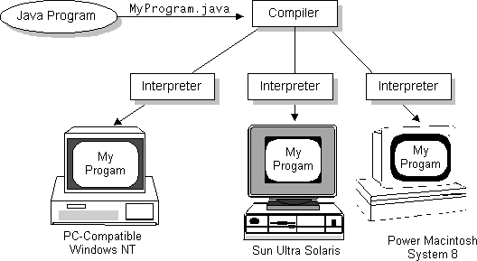](Documents%20and%20Settings/user1.USER.001/tutorial/figures/getStarted/2comp.gif)

### The Java Platform

A platform is the hardware or software environment in which a program runs. The Java platform differs from most other platforms in that it's a software-only platform that runs on top of other, hardware-based platforms. Most other platforms are described as a combination of hardware and operating system.

**The Java platform has two components:**

* The *Java Virtual Machine* (Java VM)
* The *Java Application Programming Interface* (Java API)

The Java API is a large collection of ready-made software components that provide many useful capabilities, such as graphical user interface (GUI) widgets. The Java API is grouped into libraries (*packages*) of related components.

The following figure depicts a Java program, such as an application or applet, that's running on the Java platform. As the figure shows, the Java API and Virtual Machine insulates the Java program from hardware dependencies.

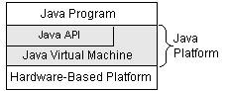

As a platform-independent environment, Java can be a bit slower than native code. However, smart compilers, well-tuned interpreters, and just-in-time byte code compilers can bring Java's performance close to that of native code without threatening portability.

## What Can Java Do?

Probably the most well-known Java programs are *Java applets*. An applet is a Java program that adheres to certain conventions that allow it to run within a Java-enabled browser.

However, Java is not just for writing cute, entertaining applets for the World Wide Web ("Web"). Java is a general-purpose, high-level programming language and a powerful software platform. Using the generous Java API, we can write many types of programs.

The most common types of programs are probably applets and applications, where a Java application is a standalone program that runs directly on the Java platform.

How does the Java API support all of these kinds of programs? With packages of software components that provide a wide range of functionality. The *core API* is the API included in every full implementation of the Java platform. The core API gives you the following features:

* **The Essentials**: Objects, strings, threads, numbers, input and output, data structures, system properties, date and time, and so on.
* **Applets**: The set of conventions used by Java applets.
* **Networking**: URLs, TCP and UDP sockets, and IP addresses.
* **Internationalization**: Help for writing programs that can be localized for users worldwide. Programs can automatically adapt to specific locales and be displayed in the appropriate language.
* **Security**: Both low-level and high-level, including electronic signatures, public/private key management, access control, and certificates.
* **Software components**: Known as JavaBeans, can plug into existing component architectures such as Microsoft's OLE/COM/Active-X architecture, OpenDoc, and Netscape's Live Connect.
* **Object serialization**: Allows lightweight persistence and communication via Remote Method Invocation (RMI).
* **Java Database Connectivity (JDBC)**: Provides uniform access to a wide range of relational databases.

Java not only has a core API, but also standard extensions. The standard extensions define APIs for 3D, servers, collaboration, telephony, speech, animation, and more.

## **How Will Java Change Life?**

Java is likely to make your programs better and requires less effort than other languages. We believe that Java will help you do the following:

* **Get started quickly**: Although Java is a powerful object-oriented language, it's easy to learn, especially for programmers already familiar with C or C++.
* **Write less code**: Comparisons of program metrics (class counts, method counts, and so on) suggest that a program written in Java can be four times smaller than the same program in C++.
* **Write better code**: The Java language encourages good coding practices, and its garbage collection helps you avoid memory leaks. Java's object orientation, its JavaBeans component architecture, and its wide-ranging, easily extendible API let you reuse other people's tested code and introduce fewer bugs.
* **Develop programs faster**: Your development time may be as much as twice as fast versus writing the same program in C++. Why? You write fewer lines of code with Java and Java is a simpler programming language than C++.
* **Avoid platform dependencies with 100% Pure Java**: You can keep your program portable by following the purity tips mentioned throughout this book and avoiding the use of libraries written in other languages.
* **Write once, run anywhere**: Because 100% Pure Java programs are compiled into machine-independent byte codes, they run consistently on any Java platform.
* **Distribute software more easily**: You can upgrade applets easily from a central server. Applets take advantage of the Java feature of allowing new classes to be loaded "on the fly," without recompiling the entire program.

We explore the java.net package, which provides support for networking. Its creators have called Java “programming for the Internet.” These networking classes encapsulate the “socket” paradigm pioneered in the Berkeley Software Distribution (BSD) from the University of California at Berkeley.

#### **Applets**

A Web page received from the Web tier can include an embedded applet. An applet is a small client application written in the Java programming language that executes in the Java virtual machine installed in the Web browser. However, client systems will likely need the Java Plug-in and possibly a security policy file in order for the applet to successfully execute in the Web browser.

Web components are the preferred API for creating a Web client program because no plug-ins or security policy files are needed on the client systems. Also, Web components enable cleaner and more modular application design because they provide a way to separate applications programming from Web page design. Personnel involved in Web page design thus do not need to understand Java programming language syntax to do their jobs.

#### **Swings**

Swing is technologically more advanced than AWT. It has much more features and functions. It has a richer set of components which can modify and change according to the library. It uses MVC which is Model View Controller Paradigm thus offering a more flexible GUI. Swing also has a built in double Buffering and at the same time is lightweight. It is also one hundred percent java based. And therefore provides icons, and also decorative and attractive borders for components and tool tips.  
  
          The only flaw is that not all swing might act like native component. Swing is required to create a Java program. This tool kit is highly complex with its customizable text package and its integrated accessibility support. Since swing is built on a 2D package it can easily enhance all animations and images. And its undo framework thus supporting innumerable editing. Thus swing definitely beats AWT in all ways.

**CHAPTER 6**

**IMPLEMENTATION**

**6.1 GENERAL**

This chapter des--cribes the implementation of THEMIS in a cloud computing environment.

**6.2 IMPLEMENTAION**

**User Interface Design**

<!DOCTYPE html PUBLIC "-//W3C//DTD XHTML 1.0 Transitional//EN" "http://www.w3.org/TR/xhtml1/DTD/xhtml1-transitional.dtd">

<html xmlns="http://www.w3.org/1999/xhtml">

<head>

<title>Cloud Service Provider</title>

<meta http-equiv="Content-Type" content="text/html; charset=utf-8" />

<link href="css/style.css" rel="stylesheet" type="text/css" />

<link rel="stylesheet" type="text/css" href="css/coin-slider.css" />

<script type="text/javascript" src="js/cufon-yui.js"></script>

<script type="text/javascript" src="js/droid_sans_400-droid_sans_700.font.js"></script>

<script type="text/javascript" src="js/jquery-1.4.2.min.js"></script>

<script type="text/javascript" src="js/script.js"></script>

<script type="text/javascript" src="js/coin-slider.min.js"></script>

<script type="text/javascript" src="Validation.js"></script>

<link rel="stylesheet" type="text/css" href="style.css" media="screen" />

</head>

<body>

</script>

<script language="javascript">

function validate_register()

{

var a=document.getElementById("name");

var b=document.getElementById("password");

var c=document.getElementById("uname");

var d=document.getElementById("rpass");

var e=document.getElementById("phone");

var f=document.getElementById("email");

var g=document.getElementById("addr");

var h=document.getElementById("acc");

var n=e.value.length;

var ac=h.value.length;

var em=f.value;

var a1=em.indexOf("@");

var b1=em.indexOf(".");

var numbers = /^[0-9]+$/;

if(a.value=="")

{

alert("Enter the Name");

a.focus();

return false;

}

else if(c.value=="")

{

alert("Enter the Username");

c.focus();

return false;

}

else if(b.value=="")

{

alert("Enter the Password");

b.focus();

return false;

}

else if(d.value=="")

{

alert("Enter the Confirm Password");

d.focus();

return false;

}

else if(d.value!=b.value)

{

alert("MisMatch Password");

d.focus();

return false;

}

else if(d.value.length!=6||b.value.length!=6)

{

alert("Password must contains 6 character");

d.focus();

return false;

}

else if(e.value=="")

{

alert("Enter the Phone Number");

e.focus();

return false;

}

else if(n!=10)

{

alert("Enter the 10 Character Phone Number");

e.focus();

return false;

}

else if(!e.value.match(numbers))

{

alert(numbers);

alert("Phone Number must be Number");

e.focus();

return false;

}

else if(f.value=="")

{

alert("Enter the Email");

f.focus();

return false;

}

else if(a1>b||a1==-1||b1==-1)

{

alert("Enter the Proper MailID");

f.focus();

return false;

}

else if(g.value=="")

{

alert("Enter the Address");

g.focus();

return false;

}

else if(h.value=="")

{

alert("Enter the Account Number");

h.focus();

return false;

}

else if(!h.value.match(numbers))

{

alert(numbers);

alert("Phone Number must be Number");

e.focus();

return false;

}

else if(ac<7)

{

alert("Account Number must be contains Above 7 Characters");

h.focus();

return false;

}

}

</script>

<div class="main">

<div class="header">

<div class="header_resize">

<div class="searchform">

<div class="top_menu"> </div>

</div>

<div class="logo">

<h1><a href="#">Cloud<span>Service Provider</span></a></h1>

</div>

<div class="clr"></div>

<div class="menu_nav">

<ul>

<li class="active"><a href="Home.jsp"><span>Home Page</span></a></li>

<li><a href="support.jsp"><span>Support</span></a></li>

<li><a href="about.jsp"><span>About Us</span></a></li>

<li><a href="contact.jsp"><span>Contact Us</span></a></li>

</ul>

</div>

<div class="clr"></div>

<div class="slider">

<div id="coin-slider">

<a href="#"><img src="images/slide1.jpg" width="960" height="360" alt="" />

<span>

<big>

Billing System

</big>

<div class="clr"></div>

</div>

<div class="clr"></div>

</div>

</div>

<div class="content">

<div class="content_resize">

<div class="mainbar">

<div class="article">

<h2><span>Excellent Solution</span> For Your Billing System</h2>

<div class="clr"></div>

<div class="img"><img src="images/img1.jpg" width="236" height="245" alt="" class="fl" /></div>

<div class="post_content">

<p><br/>

We built a billing management system that allows you to worry about building your business, not your billing system. Chargify can help you: <br/><br/>

<img src="images/checked.gif">Charge your customers’ credit cards securely<br/>

<img src="images/checked.gif">Get real-time insight into orders & revenue<br/>

<img src="images/checked.gif">Manage the dunning process when cards fail<br/>

<img src="images/checked.gif">Handle free trials, promotions, refunds & more<br/>

<img src="images/checked.gif">Charge customers on a per-usage basis<br/>

</p>

</div>

</div>

</div>

<div class="sidebar">

<div class="gadget">

<h2 class="star"><span></span>Registration</h2>

<div class="clr"></div>

<ul class="sb_menu">

<table>

<tr>

<br/>

</tr>

<tr>

<td>

Name

</td>

<td>

<input type="text" id="name" name="username"/>

</td>

</tr>

<tr>

<td>

Username

</td>

<td>

<input type="text" id="uname" name="username"/>

</td>

</tr>

<tr>

<td>

Password

</td>

<td>

<input type="password" id="password" name="password"/>

</td>

</tr>

<tr>

<td>

Confirm Password

</td>

<td>

<input type="password" id="rpass" name="rpassword"/>

</td>

</tr>

<tr>

<td>

Phone Number

</td>

<td>

<input type="text" id="phone" name="password"/>

</td>

</tr>

<tr>

<td>

Email

</td>

<td>

<input type="text" id="email" name="password"/>

</td>

</tr>

<tr>

<td>

Address

</td>

<td>

<textarea name="addr" id="addr"></textarea>

</td>

</tr>

<tr>

<td>

Account Number

</td>

<td>

<input type="password" id="acc" name="acc"/>

</td>

</tr>

<tr>

<td>

<input type="submit" value="Register" onclick="return validate_register()"/>

</td>

</tr>

</table>

</ul>

</div>

</div>

<div class="clr"></div>

</div>

</div>

<div class="fbg">

<div class="fbg_resize">

<div class="col c1">

<h2><span>Image</span> Gallery</h2>

<a href="#"><img src="images/gal1.jpg" width="75" height="75" alt="" class="gal" /></a> <a href="#"><img src="images/gal2.jpg" width="75" height="75" alt="" class="gal" /></a> <a href="#"><img src="images/gal3.jpg" width="75" height="75" alt="" class="gal" /></a> <a href="#"><img src="images/gal4.jpg" width="75" height="75" alt="" class="gal" /></a> <a href="#"><img src="images/gal5.jpg" width="75" height="75" alt="" class="gal" /></a> <a href="#">

<img src="images/gal6.jpg" width="75" height="75" alt="" class="gal" /></a> </div>

<div class="col c2">

<h2><span>Services</span> Overview</h2>

**Cloud Service Provider**

/**

* Servlet implementation class CSP_Homepage

*/

public class CSP_Homepage extends HttpServlet {

private static final long serialVersionUID = 1L;

/**

* @see HttpServlet#HttpServlet()

*/

public CSP_Homepage() {

super();

// TODO Auto-generated constructor stub

}

/**

* @see HttpServlet#doGet(HttpServletRequest request, HttpServletResponse response)

*/

protected void doGet(HttpServletRequest request, HttpServletResponse response) throws ServletException, IOException {

// TODO Auto-generated method stub

}

/**

* @see HttpServlet#doPost(HttpServletRequest request, HttpServletResponse response)

*/

protected void doPost(HttpServletRequest request, HttpServletResponse response) throws ServletException, IOException

{

String admin_name=request.getParameter("username");

String admin_pass=request.getParameter("password");

HttpSession hs=request.getSession();

hs.setAttribute("username", admin_name);

if((admin_name.equalsIgnoreCase("admin"))&&(admin_pass.equalsIgnoreCase("admin")))

{

RequestDispatcher rd= request.getRequestDispatcher("CSP_Homepage.jsp");

rd.forward(request,response);

}

}

}

public class Upload extends HttpServlet {

protected void processRequest(HttpServletRequest request, HttpServletResponse response)

throws ServletException, IOException {

response.setContentType("text/html;charset=UTF-8");

PrintWriter out = response.getWriter();

ServletContext context=getServletContext();

try

{

String contentType = request.getContentType();

System.out.println("content type "+contentType);

if ((contentType != null) && (contentType.indexOf("multipart/form-data") >= 0)) {

DataInputStream in = new DataInputStream(request.getInputStream());

//we are taking the length of Content type data

int formDataLength = request.getContentLength();

byte dataBytes[] = new byte[formDataLength];

int byteRead = 0;

int totalBytesRead = 0;

//this loop converting the uploaded file into byte code

while (totalBytesRead < formDataLength)

{

byteRead = in.read(dataBytes, totalBytesRead, formDataLength);

totalBytesRead += byteRead;

}

fileSize=dataBytes.length;

String file = new String(dataBytes);

//for saving the file name

// System.out.println("file is nnnnnnnnnnn="+file+"xxxxxxxxxxxxxxx");

String saveFile = file.substring(file.indexOf("filename=\"") + 10);

// System.out.println("save file is "+file);

saveFile = saveFile.substring(0, saveFile.indexOf("\n"));

saveFile = saveFile.substring(saveFile.lastIndexOf("\\") + 1, saveFile.indexOf("\""));

int lastIndex = contentType.lastIndexOf("=");

String boundary = contentType.substring(lastIndex + 1, contentType.length());

int pos;

//extracting the index of file

pos = file.indexOf("filename=\"");

pos = file.indexOf("\n", pos) + 1;

pos = file.indexOf("\n", pos) + 1;

pos = file.indexOf("\n", pos) + 1;

int boundaryLocation = file.indexOf(boundary, pos) - 4;

int startPos = ((file.substring(0, pos)).getBytes()).length;

int endPos = ((file.substring(0, boundaryLocation)).getBytes()).length;

String path = request.getRealPath("");

System.out.println("path="+path);

System.out.println("saved name is"+saveFile);

String uploadedfile=context.getInitParameter("uploadedpath");

FileOutputStream fileOut = new FileOutputStream(uploadedfile+"\\"+saveFile);

fileOut.write(dataBytes, startPos, (endPos - startPos));

fileOut.flush();

fileOut.close();

HttpSession hs=request.getSession();

hs.setAttribute("filename", saveFile);

// al=(ArrayList)PublicDBClass.singleton().getFileNames(UserName);

// hs.setAttribute("filenames",al);

RequestDispatcher rdp=request.getRequestDispatcher("AfterUpload.jsp");

rdp.forward(request, response);

}

else

{

System.out.println("file not uploaded");

}

String ContentType;

byte[] b;

} finally {

out.close();

}

}

// <editor-fold defaultstate="collapsed" desc="HttpServlet methods. Click on the + sign on the left to edit the code.">

@Override

protected void doGet(HttpServletRequest request, HttpServletResponse response)

throws ServletException, IOException {

processRequest(request, response);

}

@Override

protected void doPost(HttpServletRequest request, HttpServletResponse response)

throws ServletException, IOException {

processRequest(request, response);

}

@Override

public String getServletInfo() {

return "Short description";

}// </editor-fold>

Connection con;

Statement st;

int fileSize;

String UserName;

ArrayList al;

}

**User**

<!DOCTYPE html PUBLIC "-//W3C//DTD XHTML 1.0 Transitional//EN" "http://www.w3.org/TR/xhtml1/DTD/xhtml1-transitional.dtd">

<html xmlns="http://www.w3.org/1999/xhtml">

<head>

<title>Cloud Service Provider</title>

<meta http-equiv="Content-Type" content="text/html; charset=utf-8" />

<link href="css/style.css" rel="stylesheet" type="text/css" />

<link rel="stylesheet" type="text/css" href="css/coin-slider.css" />

<script type="text/javascript" src="js/cufon-yui.js"></script>

<script type="text/javascript" src="js/droid_sans_400-droid_sans_700.font.js"></script>

<script type="text/javascript" src="js/jquery-1.4.2.min.js"></script>

<script type="text/javascript" src="js/script.js"></script>

<script type="text/javascript" src="js/coin-slider.min.js"></script>

<link rel="stylesheet" type="text/css" href="style.css" media="screen" />

</head>

<body>

<script language="javascript">

function validate()

{

var a=document.getElementById("name");

var b=document.getElementById("pass");

if(a.value=="")

{

alert("Enter the Username");

a.focus();

return false;

}

else if(b.value=="")

{

alert("Enter the Password");

b.focus();

return false;

}

}

</script>

<div class="main">

<div class="header">

<div class="header_resize">

<div class="searchform">

<div class="top_menu"> </div>

</div>

<div class="logo">

<h1><a href="#">Cloud<span>Service Provider</span></a></h1>

</div>

<div class="clr"></div>

<div class="menu_nav">

<ul>

<li class="active"><a href="Home.jsp"><span>Home Page</span></a></li>

<li><a href="support.jsp"><span>Support</span></a></li>

<li><a href="about.jsp"><span>About Us</span></a></li>

<li><a href="contact.jsp"><span>Contact Us</span></a></li>

</ul>

</div>

<div class="clr"></div>

<div class="slider">

<div id="coin-slider">

<a href="#"><img src="images/slide1.jpg" width="960" height="360" alt="" />

<span>

<div class="sidebar">

<div class="gadget">

<h2 class="star"><span></span>Login</h2>

<div class="clr"></div>

<ul class="sb_menu">

<form name="form" method="post" action="CSP_Homepage" >

<table>

<tr>

<br/>

</tr>

<tr>

<td>

Username

</td>

<td>

<input type="text" id="name" name="username"/>

</td>

</tr>

<tr>

<td>

Password

</td>

<td>

<input type="password" id="pass" name="password"/>

</td>

</tr>

<tr>

<td>

<input type="submit" value="Login" onclick="return validate()"/>

</td>

<td>

<a href="Register.jsp"><font color="white">REGISTER</font></a>

</td>

</tr>

</table>

</ul>

</div>

</div>

<div class="clr"></div>

</div>

</div>

<div class="fbg">

<div class="fbg_resize">

<div class="col c1"> <ul class="fbg_ul">

<li><a href="http://en.wikipedia.org/wiki/Cloud_computing">Cloud Computing</a></li>

<li><a href="http://searchdatabackup.techtarget.com/definition/cloud-backup">cloud backup</a></li>

<li><a href="http://searchcloudcomputing.techtarget.com/definition/cloud-computing">Hybrid cloud.</a></li>

</ul>

</div>

<div class="col c3">

<h2><span>Contact</span> Us</h2>

<p></p>

<p class="contact_info"> <span>Address:</span>1458 chennai, India<br />

<span>Telephone:</span> +123-1234-5678 <img src="images/images (1).jpg" width="18" height="16" alt="" /><br />

<span>FAX:</span> +458-4578<br />

<span>Others:</span> +301 - 0125 - 01258<br />

<span>E-mail:</span> <a href="#">abc@cloud.com</a> </p>

</div>

<div class="clr"></div>

</div>

</div>

<div class="footer">

<div class="footer_resize">

<div style="clear:both;"></div>

</div>

</div>

</div>

<div align=center></div></body>

</html>

**Cloud Notary Authority (CNA)**

public class receiveSLA extends HttpServlet {

String saveFile,uploadedfile;

private static final long serialVersionUID = 1L;

/**

* @see HttpServlet#HttpServlet()

*/

public receiveSLA() {

super();

// TODO Auto-generated constructor stub

}

/**

* @see HttpServlet#doGet(HttpServletRequest request, HttpServletResponse response)

*/

protected void doGet(HttpServletRequest request, HttpServletResponse response) throws ServletException, IOException {

// TODO Auto-generated method stub

}

/**

* @see HttpServlet#doPost(HttpServletRequest request, HttpServletResponse response)

*/

protected void processRequest(HttpServletRequest request, HttpServletResponse response)

throws ServletException, IOException {

response.setContentType("text/html;charset=UTF-8");

PrintWriter out = response.getWriter();

ServletContext context=getServletContext();

String status=request.getParameter("name");

try

{

String contentType = request.getContentType();

System.out.println("content type "+contentType);

if ((contentType != null) && (contentType.indexOf("multipart/form-data") >= 0)) {

DataInputStream in = new DataInputStream(request.getInputStream());

//we are taking the length of Content type data

int formDataLength = request.getContentLength();

byte dataBytes[] = new byte[formDataLength];

int byteRead = 0;

int totalBytesRead = 0;

//this loop converting the uploaded file into byte code

while (totalBytesRead < formDataLength)

{

byteRead = in.read(dataBytes, totalBytesRead, formDataLength);

totalBytesRead += byteRead;

}

int fileSize=dataBytes.length;

String file = new String(dataBytes);

//for saving the file name

// System.out.println("file is nnnnnnnnnnn="+file+"xxxxxxxxxxxxxxx");

saveFile= file.substring(file.indexOf("filename=\"") + 10);

// System.out.println("save file is "+file);

saveFile = saveFile.substring(0, saveFile.indexOf("\n"));

saveFile = saveFile.substring(saveFile.lastIndexOf("\\") + 1, saveFile.indexOf("\""));

int lastIndex = contentType.lastIndexOf("=");

String boundary = contentType.substring(lastIndex + 1, contentType.length());

int pos;

//extracting the index of file

pos = file.indexOf("filename=\"");

pos = file.indexOf("\n", pos) + 1;

pos = file.indexOf("\n", pos) + 1;

pos = file.indexOf("\n", pos) + 1;

int boundaryLocation = file.indexOf(boundary, pos) - 4;

int startPos = ((file.substring(0, pos)).getBytes()).length;

int endPos = ((file.substring(0, boundaryLocation)).getBytes()).length;

// creating a new file with the same name and writing the content in new file

String path = request.getRealPath("");

System.out.println("path="+path);

System.out.println("saved name is"+saveFile);

// FileOutputStream fileOut = new FileOutputStream("D:\\VIVEK\\ITJCC04\\ITJCC04\\PUBLIC CLOUD\\build\\web\\"+saveFile);

uploadedfile =context.getInitParameter("uploadedpath");

FileOutputStream fileOut = new FileOutputStream(uploadedfile+"\\"+saveFile);

fileOut.write(dataBytes, startPos, (endPos - startPos));

fileOut.flush();

fileOut.close();

HttpSession hs=request.getSession();

hs.setAttribute("filename", saveFile);

String[] s=saveFile.split("-");

String name=s[0];

System.out.println(s[1]+"hnhnhnhnh");

String path1="E:/THEMIS/ITJCC05-Themis/WebContent/SLA"+"/"+saveFile;

int p=s[1].indexOf(".");

String sw=s[1].substring(0,p);

System.out.println(s[1]+"gggggg"+name+"jjjjjjjjjjjjjjjjjjjjjjjjjjjjjjjjjjjjjjjjj"+path1+"ioio"+sw);

try

{

DBClass1 db= new DBClass1();

System.out.println("db con is "+db);

java.sql.Connection cont=db.connect();

System.out.println("hghghg"+cont);

/*java.sql.Connection con=Dbcontion.getinstance().connect();

System.out.println(con+":::::::::::::::::::::::::::::::::::::::");*/

Statement st= cont.createStatement();

int j=st.executeUpdate("insert into receivesla values('"+name+"','"+path1+"','"+0+"','"+sw+"','"+0+"')");

System.out.println("insert into receivesla values('"+name+"','"+path1+"','"+0+"','"+sw+"')");

}

catch(Exception e)

{

e.printStackTrace();

}

response.sendRedirect("http://localhost:8080/ITJCC05/Bill1.jsp");

/*RequestDispatcher rdp=request.getRequestDispatcher();

dp.forward(request, response);*/

}

else

{

System.out.println("file not uploaded");

}

String ContentType;

byte[] b;

}

package db;

import java.sql.Connection;

import java.sql.DriverManager;

public class DBClass1 implements Interface_DBClass

{

Connection con=null;

String url = "jdbc:mysql://192.168.0.9:3306/";

String dbName = "itjcc05-themis";

String driver = "com.mysql.jdbc.Driver";

String userName = "root";

String password = "root";

public Connection connect()

{

try

{

System.out.println("hi");

Class.forName(driver);

con=DriverManager.getConnection(url+dbName,userName,password);

}

catch(Exception e)

{

System.out.println(e);

}

return con;

}

}

**Monitor**

public monitorcopy() {

super();

// TODO Auto-generated constructor stub

}

/**

* @see HttpServlet#doGet(HttpServletRequest request, HttpServletResponse response)

*/

protected void doGet(HttpServletRequest request, HttpServletResponse response) throws ServletException, IOException

{

System.out.println("monitor hit");

String val=null,cost=null,image=null,phone=null,mail=null,address=null,id=null,date=null;

HttpSession hs= request.getSession();

String file=hs.getAttribute("file").toString();

response.setContentType("text/html; charset=utf-8" );

String pat=getServletContext().getInitParameter("Monitorpath");

System.out.println("file name is"+file+" "+pat);

String[] s= file.split("-");

String name=s[0];

System.out.println(name+" "+s[1]);

int p=s[1].indexOf(".");

String sw=s[1].substring(0,p);

System.out.println(sw);

DBClass2 db= new DBClass2();

System.out.println("db con is "+db);

java.sql.Connection cont=db.connect();

System.out.println("hghghg"+cont);

List l= new ArrayList();

try

{

Statement st= cont.createStatement();

System.out.println("Select validity,cost,image from upload where name='"+sw+"'");

ResultSet rs=st.executeQuery("Select validity,cost,image from upload where name='"+sw+"'");

while(rs.next())

{

val=rs.getString(1);

cost=rs.getString(2);

image=rs.getString(3);

System.out.println(val+" "+cost+" "+image);

}

Statement st1= cont.createStatement();

ResultSet rs1=st1.executeQuery("Select phone_no,email_id,address from user where user_name='"+name+"'");

while(rs1.next())

{

phone=rs1.getString(1);

mail=rs1.getString(2);

address=rs1.getString(3);

System.out.println(phone+" "+mail+" "+address);

}

System.out.println(phone+" gggbbbb "+mail+" "+address);

Statement st2= cont.createStatement();

ResultSet rs2=st2.executeQuery("Select id,date from response where user='"+name+"' and software='"+sw+"'");

while(rs2.next())

{

id=rs2.getString(1);

date=rs2.getString(2);

System.out.println(id+" "+" "+date);

}

System.out.println(id+" nnn "+" "+date);

l.add(name);

l.add(mail);

l.add(phone);

l.add(address);

l.add(sw);

l.add(val);

l.add(cost);

l.add(image);

l.add(id);

l.add(date);

l.add(pat);

/*String pat=getServletContext().getInitParameter("Monitorpath");

sla.add(pat);*/

SlaPDF sl= new SlaPDF();

sl.sla(l);

request.setAttribute("sname", sw);

request.setAttribute("uname",name);

RequestDispatcher rd=request.getRequestDispatcher("Monitor\\"+file);

rd.forward(request, response);

}

catch(Exception e)

{

e.printStackTrace();

}

}

**Action against SLA violation**

public class Compare_monitor

{

String orgl=null;

public void pdf(String path)

{

try

{

Document document = new Document();

document.open();

PdfReader reader = new PdfReader("E:\\THEMIS\\ITJCC05-Themis\\WebContent\\Monitor\\"+path);

PdfDictionary dictionary = reader.getPageN(1);

PRIndirectReference reference = (PRIndirectReference) dictionary

.get(PdfName.CONTENTS);

PRStream stream = (PRStream) PdfReader.getPdfObject(reference);

byte[] bytes = PdfReader.getStreamBytes(stream);

PRTokeniser tokenizer = new PRTokeniser(bytes);

StringBuffer buffer = new StringBuffer();

while (tokenizer.nextToken()) {

if (tokenizer.getTokenType() == PRTokeniser.TK_STRING) {

buffer.append(tokenizer.getStringValue());

}

}

orgl = buffer.toString();

System.out.println("monitor copy"+orgl);

} catch (Exception e)

{

e.printStackTrace();

}

}

public String compare_with_monitor(List copy,String path)

{

System.out.println("copy is"+copy);

String CSP_copy=copy.get(8).toString();

String user_copy=copy.get(9).toString();

System.out.println("ddddddddd");

String cond=null;

pdf(path);

if(!(CSP_copy.equals(orgl)))

{

cond="CSP";

}

if(!(user_copy.equals(orgl)))

{

cond="user";

}

System.out.println("condition is "+cond);

return cond;

}

}

protected void doGet(HttpServletRequest request, HttpServletResponse response) throws ServletException, IOException {

// TODO Auto-generated method stub

String abc=(String)request.getParameter("us");

String cc=request.getParameter("sw");

System.out.println("abc is "+abc+" "+cc);

status=Example1.compare(abc);

System.out.println(status.size());

ServletContext context=getServletContext();

String Billpath=context.getInitParameter("Billpath");

if(status.size()==8)

{

try{

BillPDF bb= new BillPDF();

String date=bb.bill(status,Billpath);

HttpSession hs= request.getSession();

hs.setAttribute("bill", date);

RequestDispatcher rd= request.getRequestDispatcher("afterbilling.jsp");

rd.forward(request, response);

}

catch(Exception e)

{

e.printStackTrace();

}

}

if(status.size()==10)

{

try{

Compare_monitor cm= new Compare_monitor();

String cond=cm.compare_with_monitor(status, abc);

status.add(cond);

BillPDF bb= new BillPDF();

String date=bb.bill(status,Billpath);

HttpSession hs= request.getSession();

hs.setAttribute("bill", date);

RequestDispatcher rd= request.getRequestDispatcher("afterbilling.jsp");

rd.forward(request, response);

}

catch(Exception e)

{

e.printStackTrace();

}

}

}

**6.3 Database Design Diagram**

Database design is the process of producing a detailed data model of a database. This logical data model contains all the needed logical and physical design choices and physical storage parameters needed to generate a design in a Data Definition Language, which can then be used to create a database. A fully attributed data model contains detailed attributes for each entity.

**Database 1:itjcc05**

**Table 1: Registration**

It contains user registration details for authenticating the users.

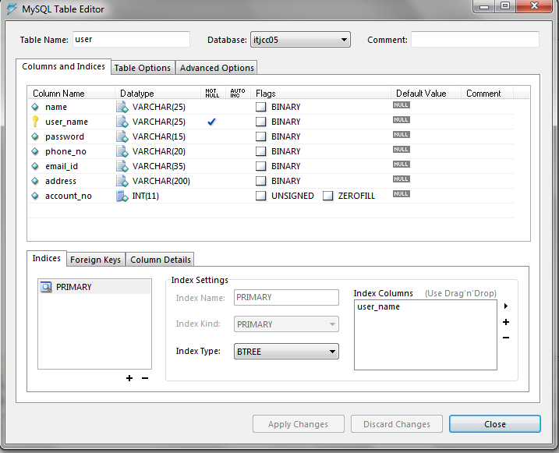

**Table 2: Upload**

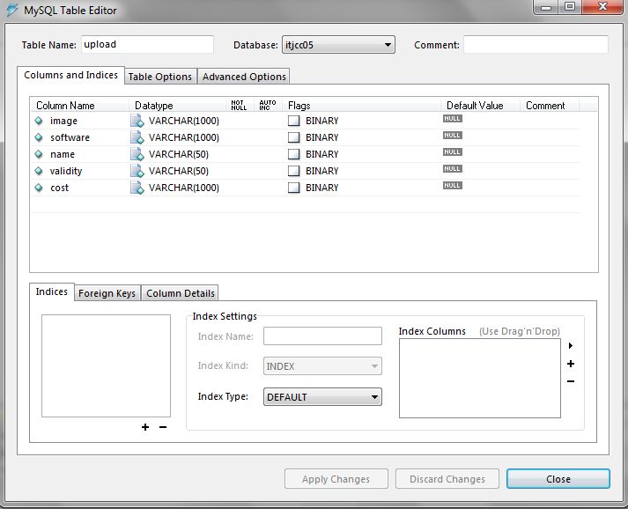

**Table 3: Request_from_user**

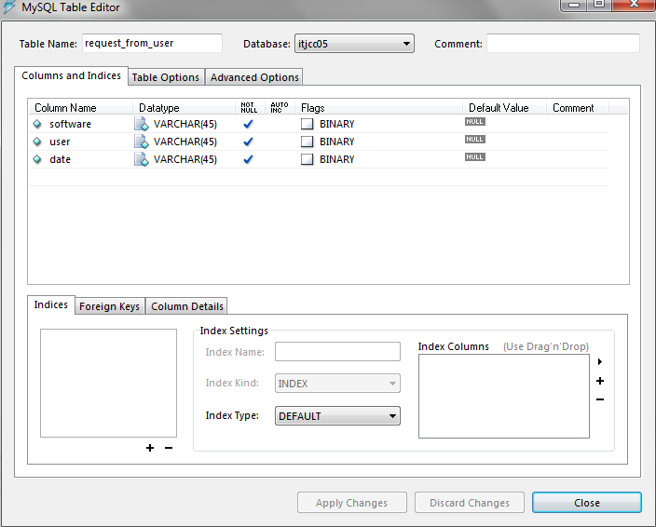

**Table 4: Response**

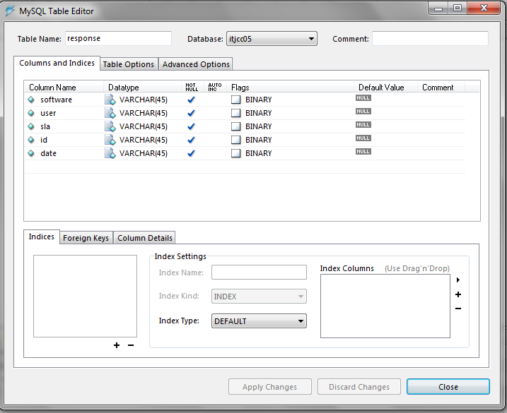

**Database 2:itjcc05-themis**

**Table 1: monitor**

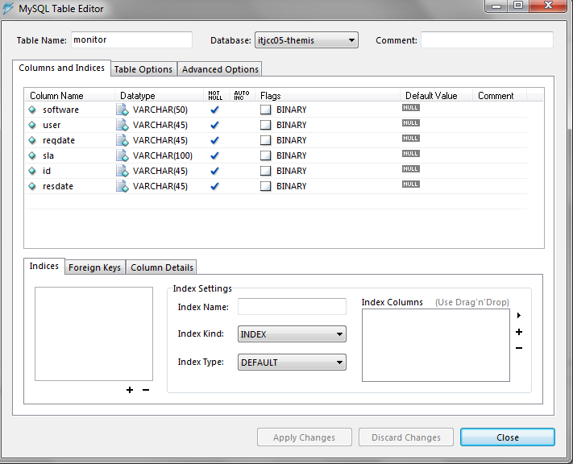

**Table 2: receivesla**

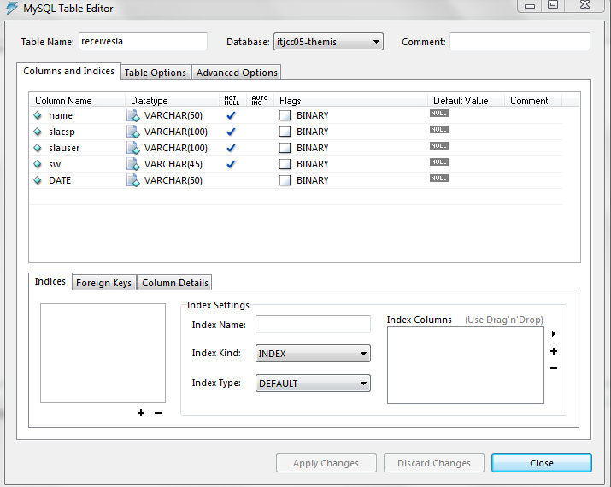

**CHAPTER 7**

**SNAPSHOTS**

**7.1 GENERAL**

Snapshot is nothing but every moment of the application while running. It gives the clear elaborated of application. It will be useful for the new user to understand for the future steps.

**7.2. VARIOUS SNAPSHOTS**

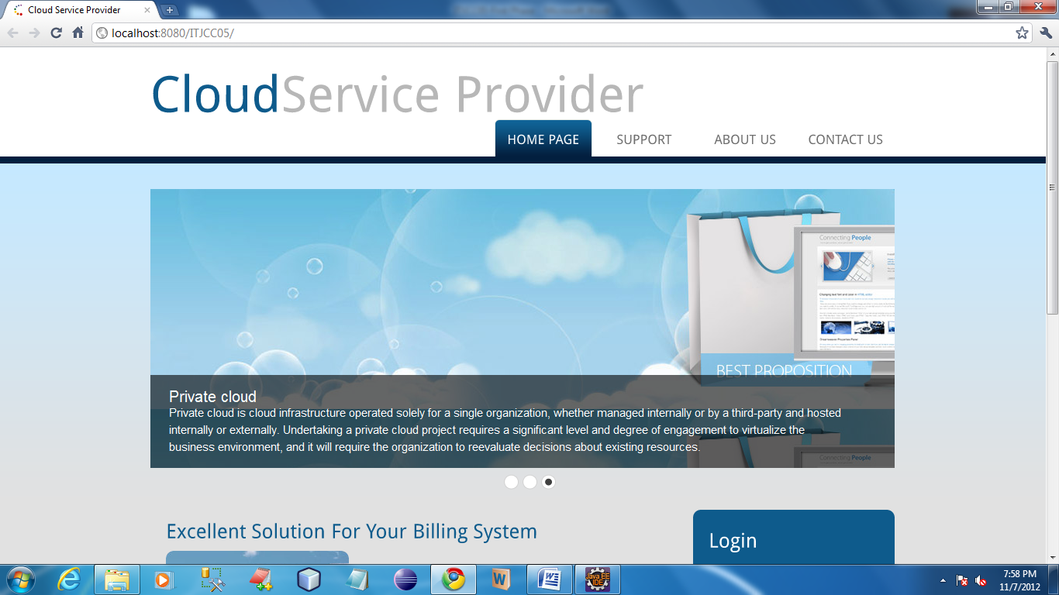

This is the home page for our Service provider webapplication.

**USER INTERFACE**

**Registration**

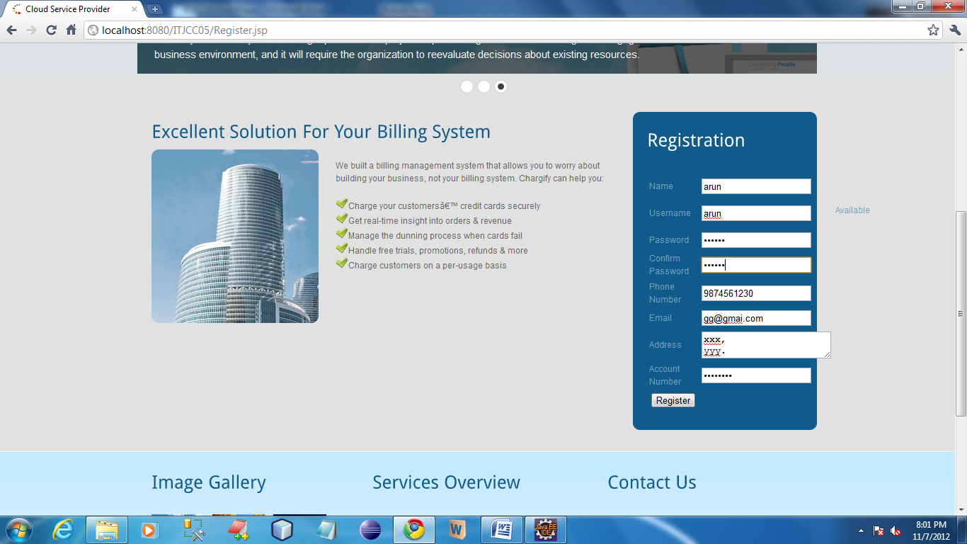

**CSP**

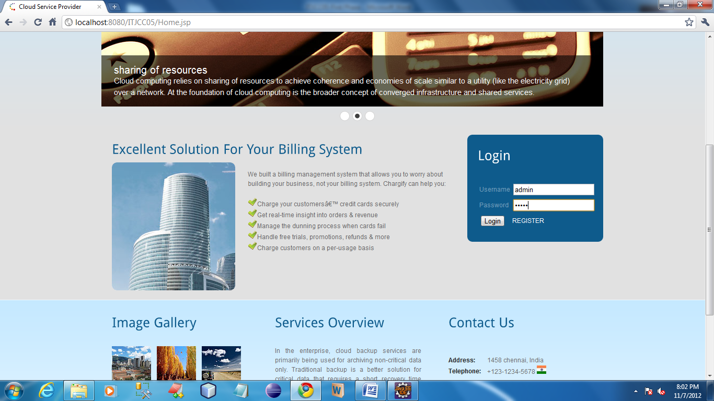

CSP login their account by using the username and password as admin and admin respectively. Once authentication finished it shows the homepage for CSP.

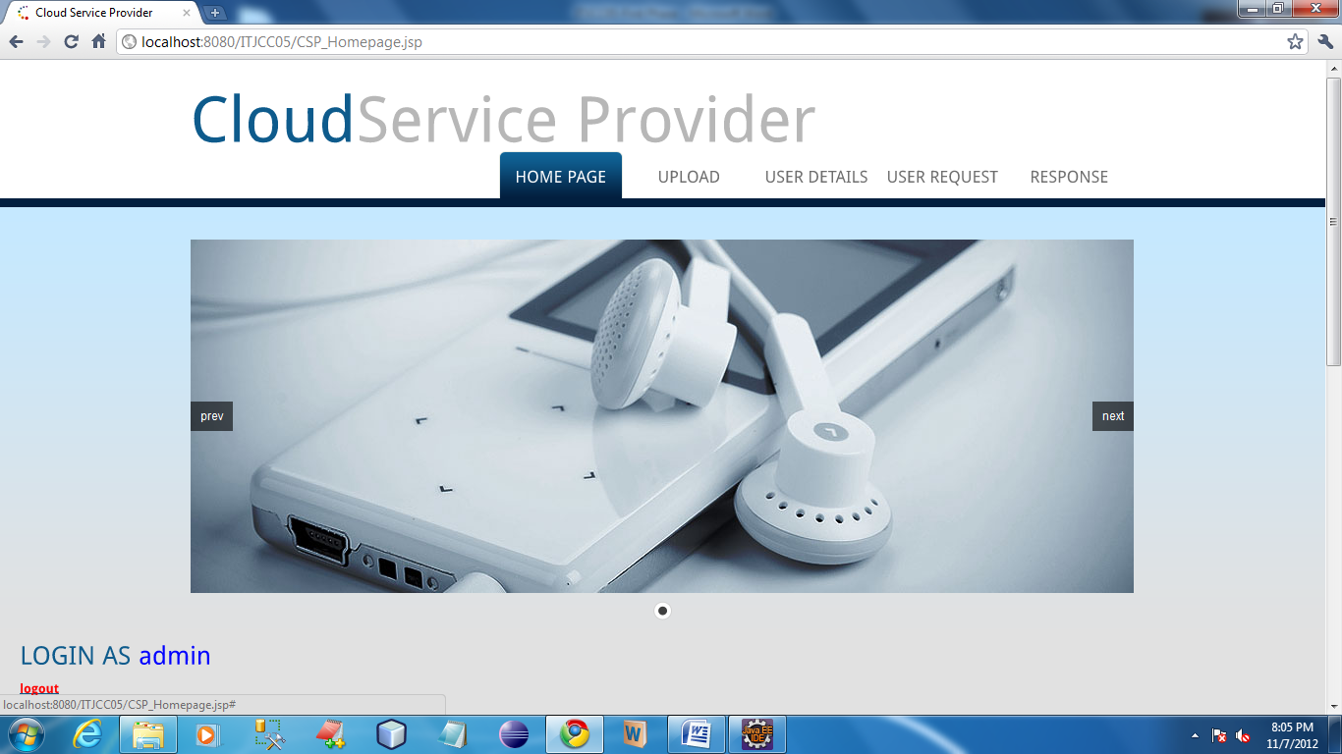

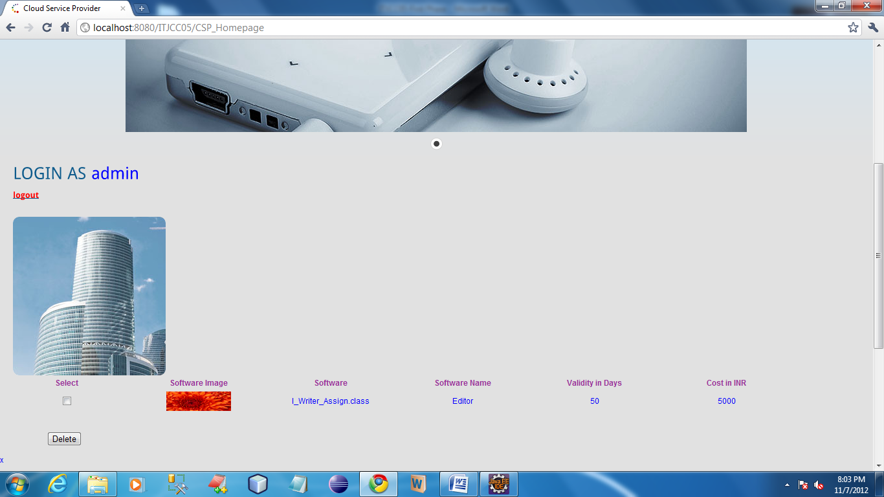

In CSP homepage all the service details can be viewed by admin.

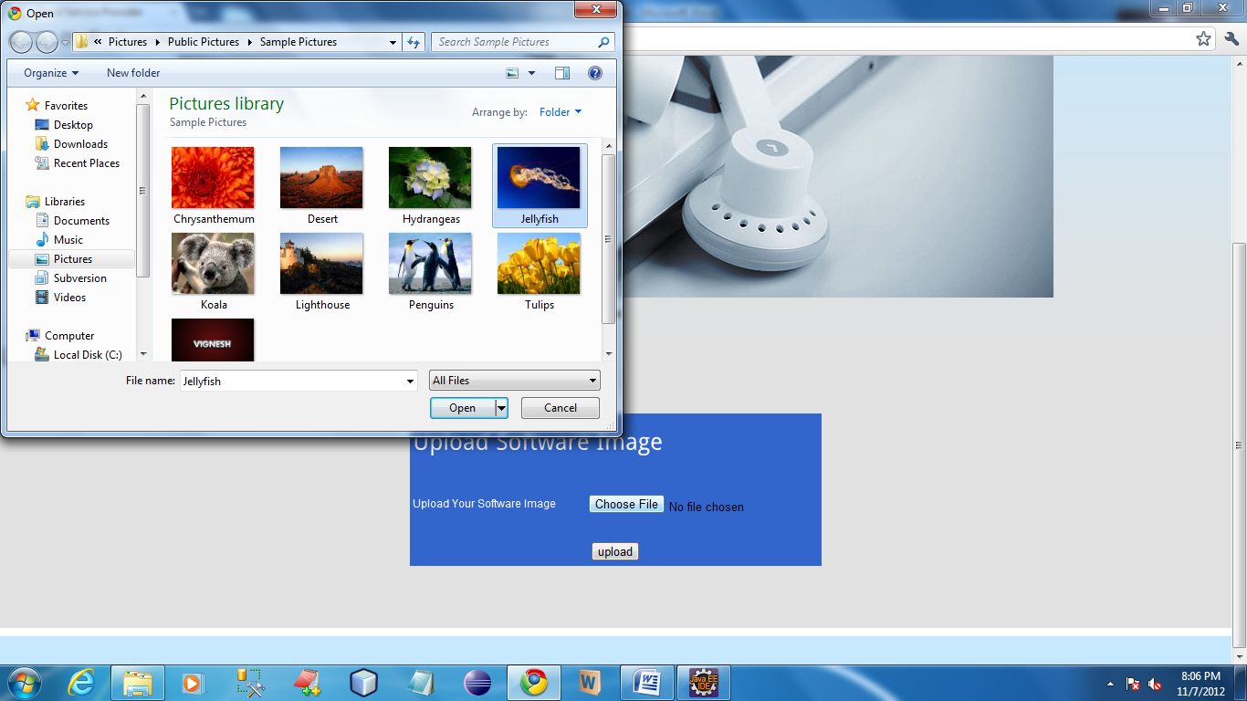

In this page admin can upload software image.

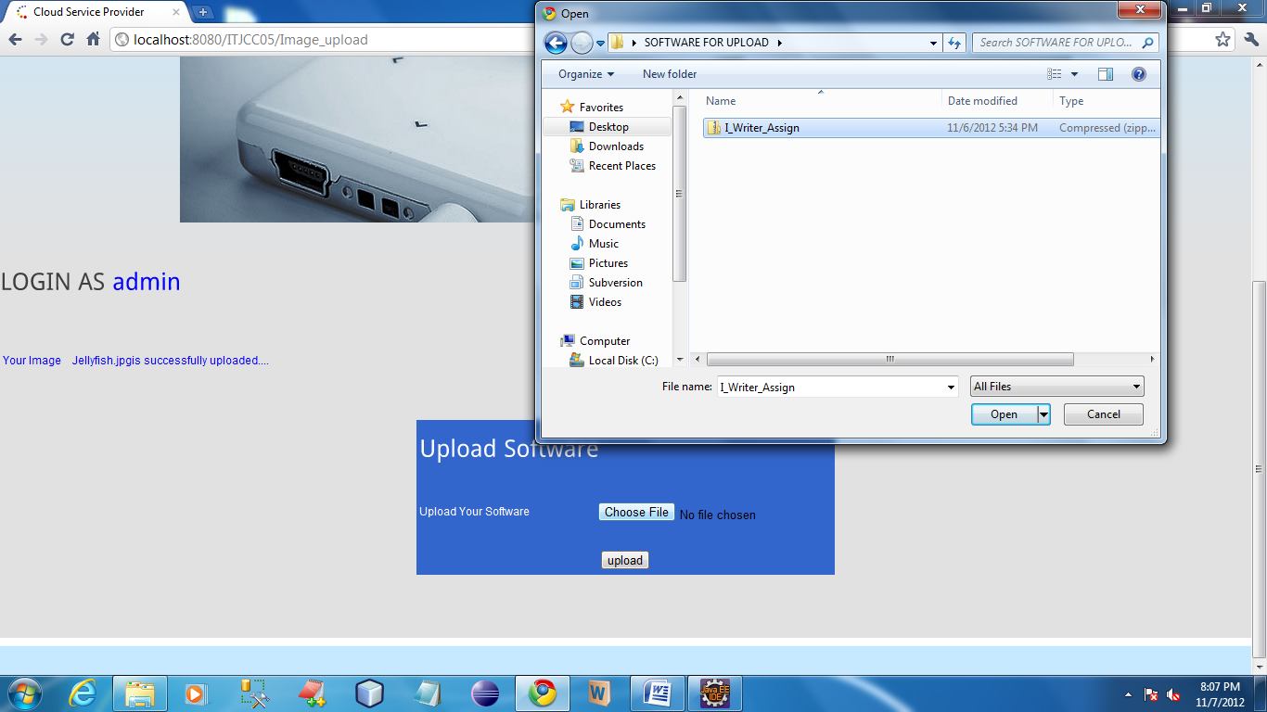

In this page user can upload their softwares which will be going to give as a service for the users.

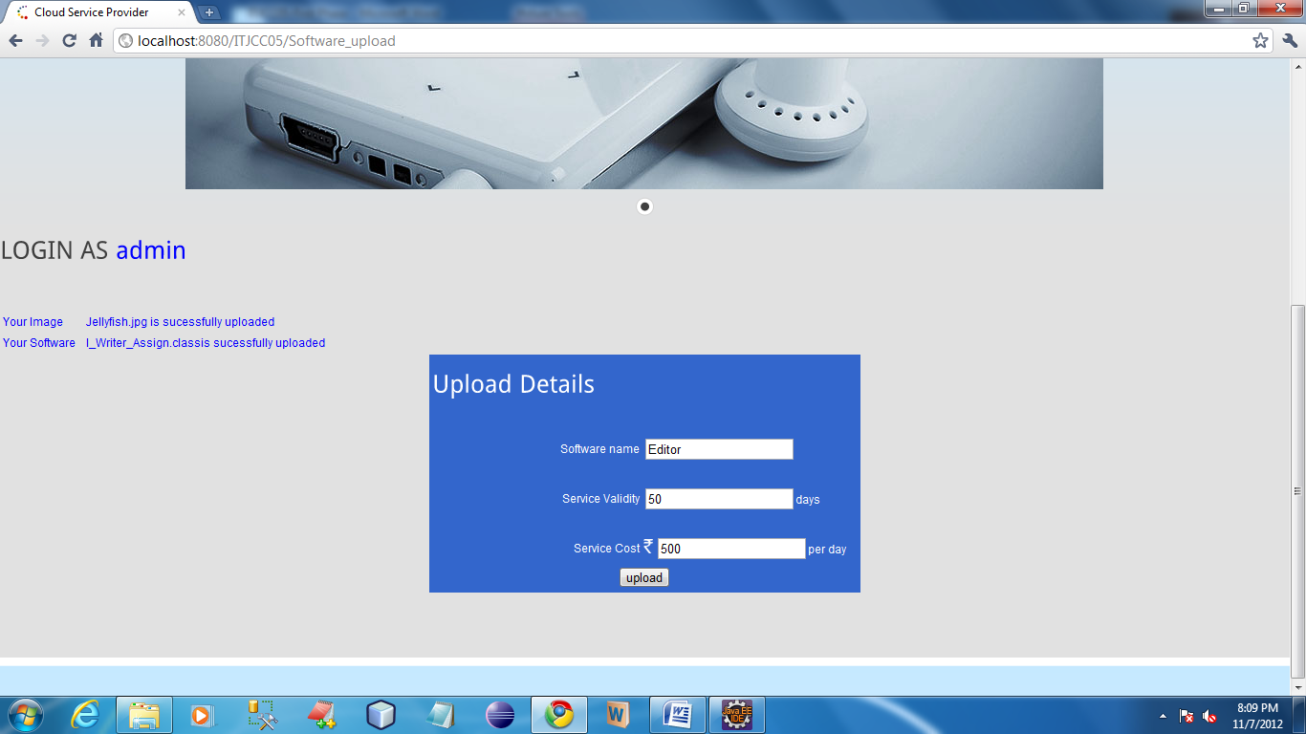

In this page admin can upload the details about software.

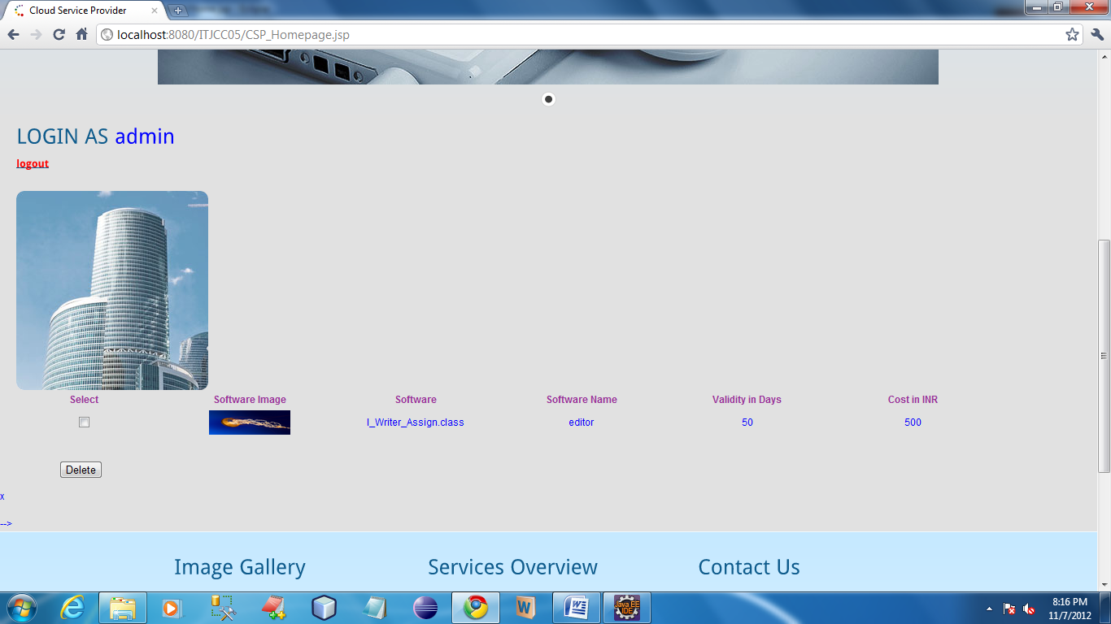

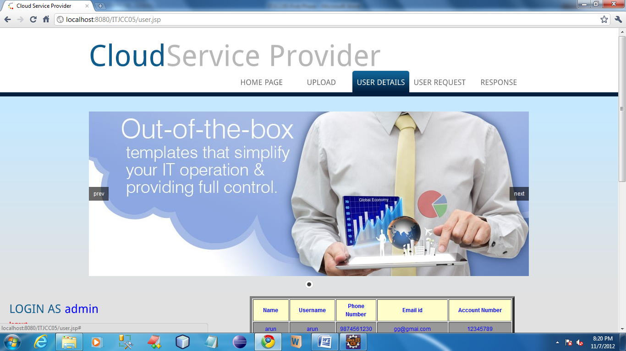

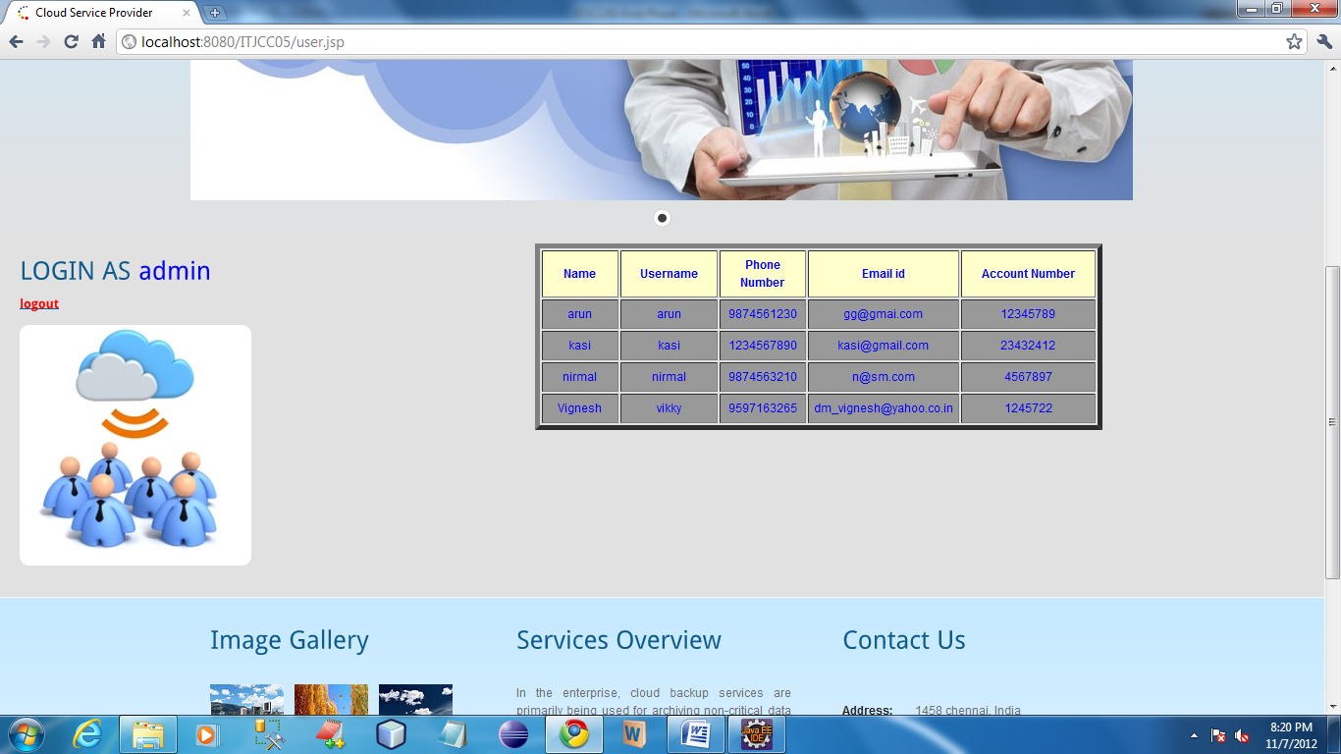

In this page admin can view their registered users who are access their service.

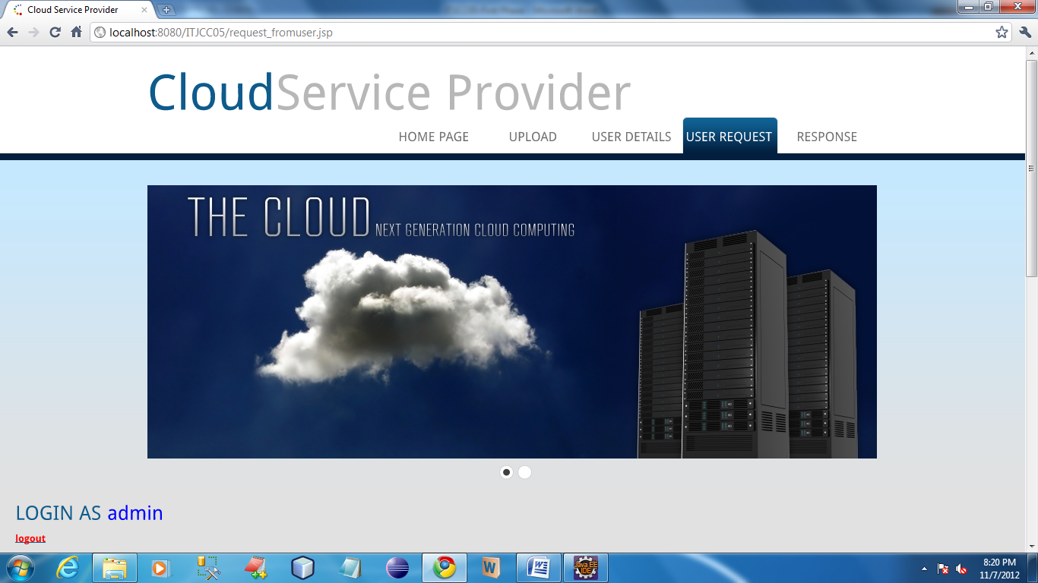

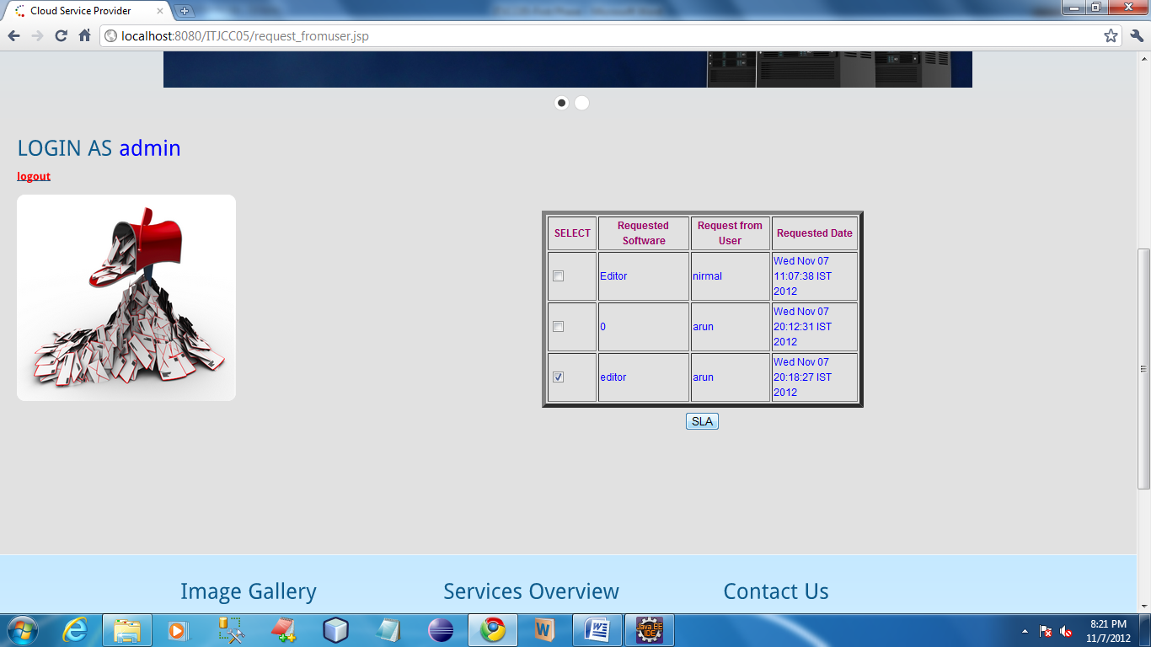

In this page admin can view the request came from user and also generate the SLA for the users.

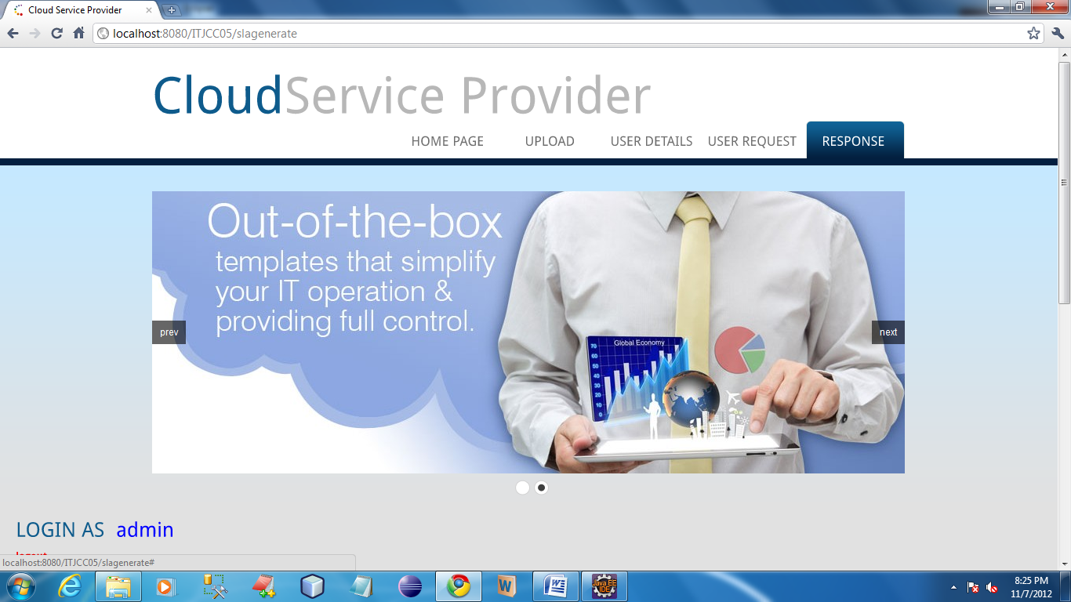

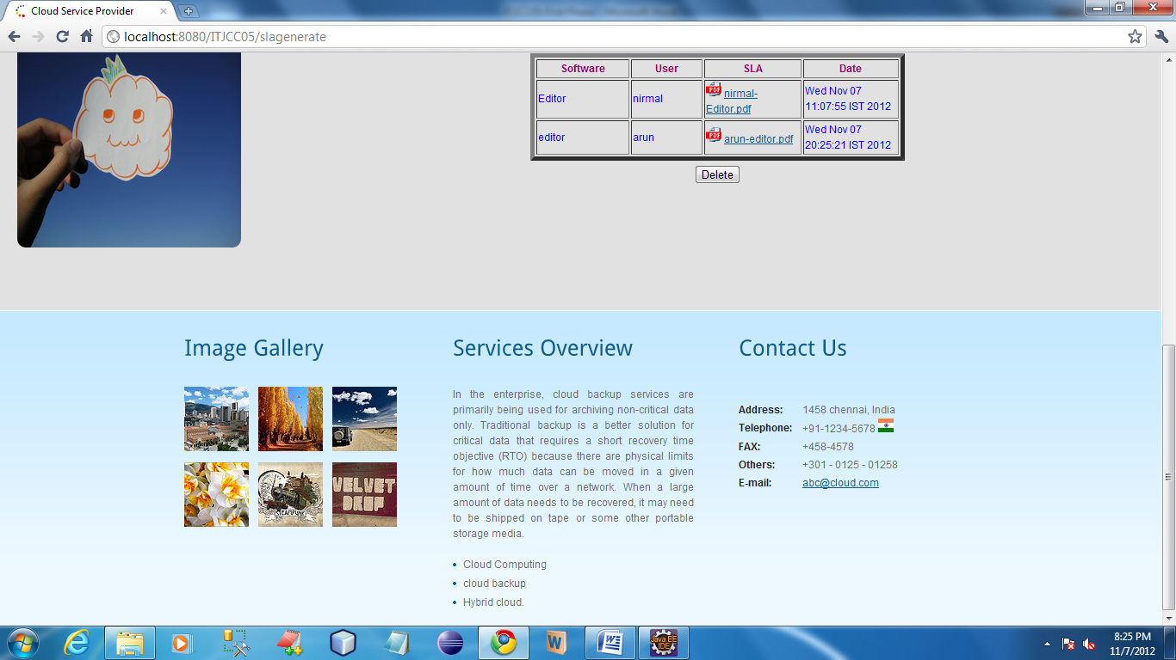

In this page admin can view the SLA for the users. By click the PDF icon admin can view the SLA.

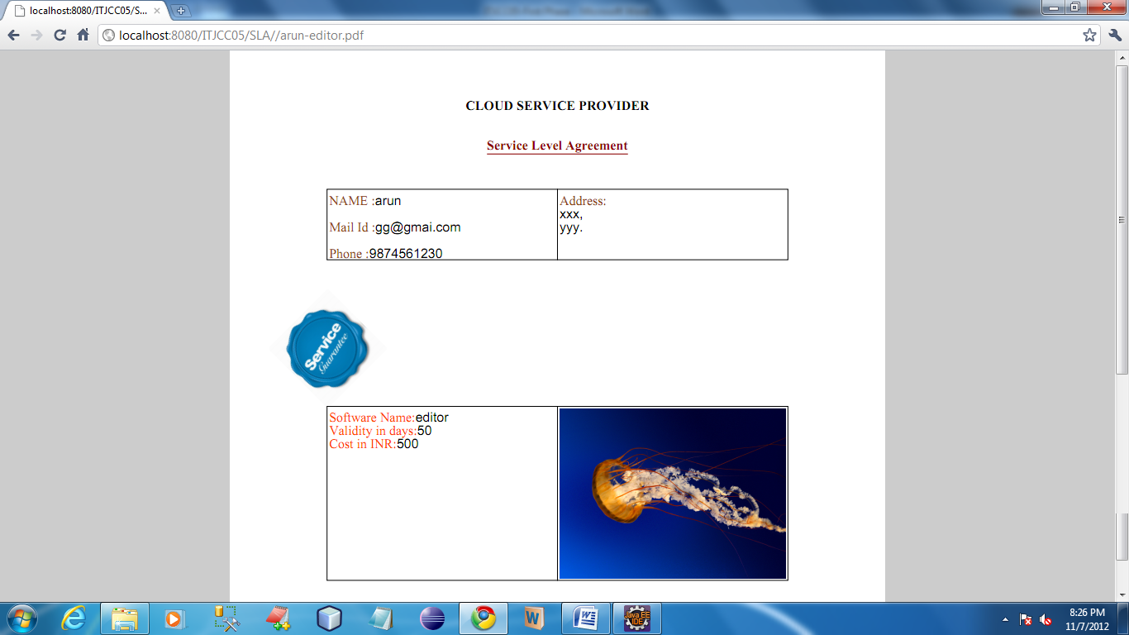

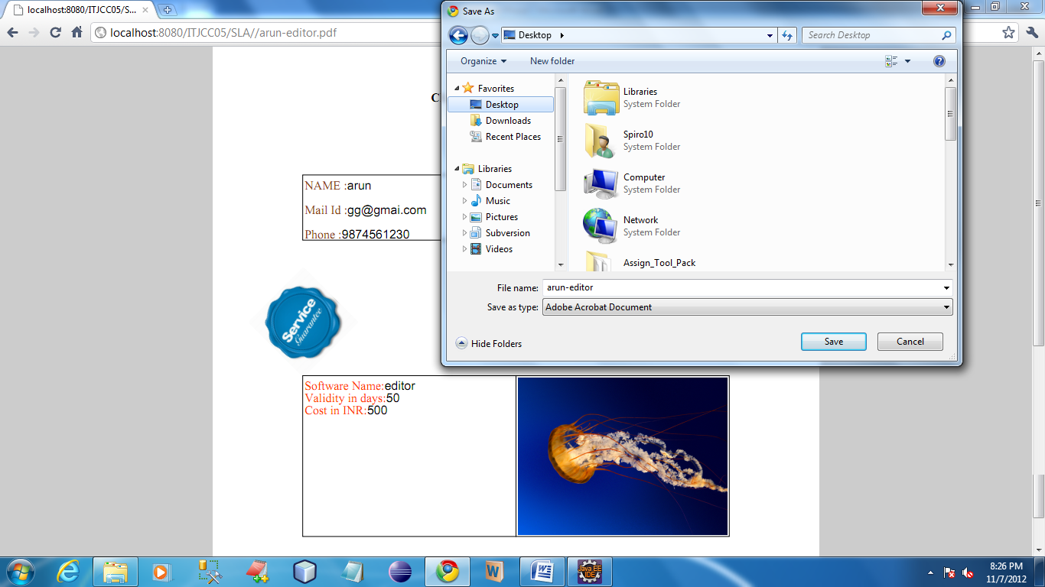

To send SLA CSP copy, csp send from following page

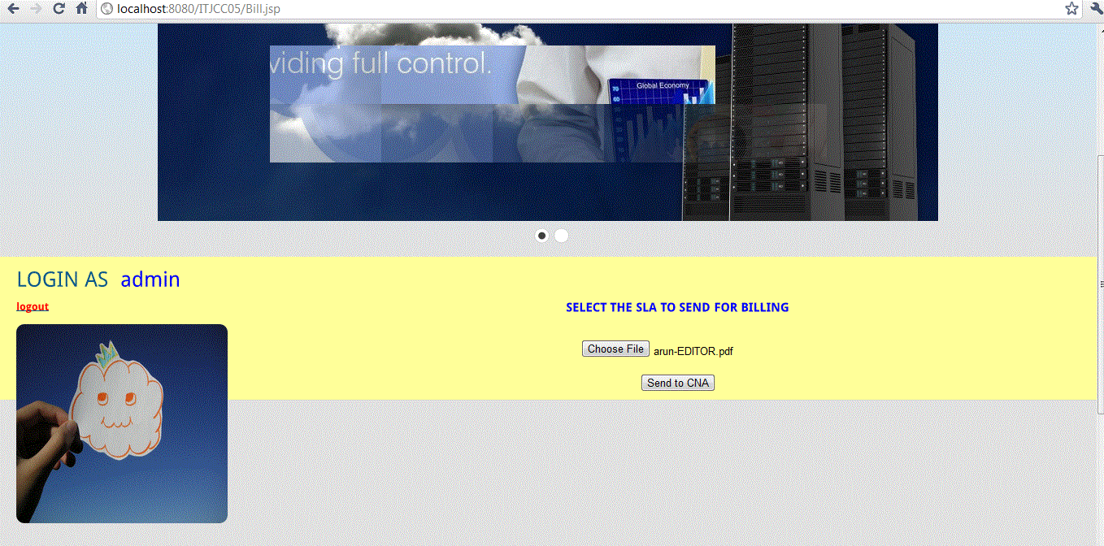

**User**

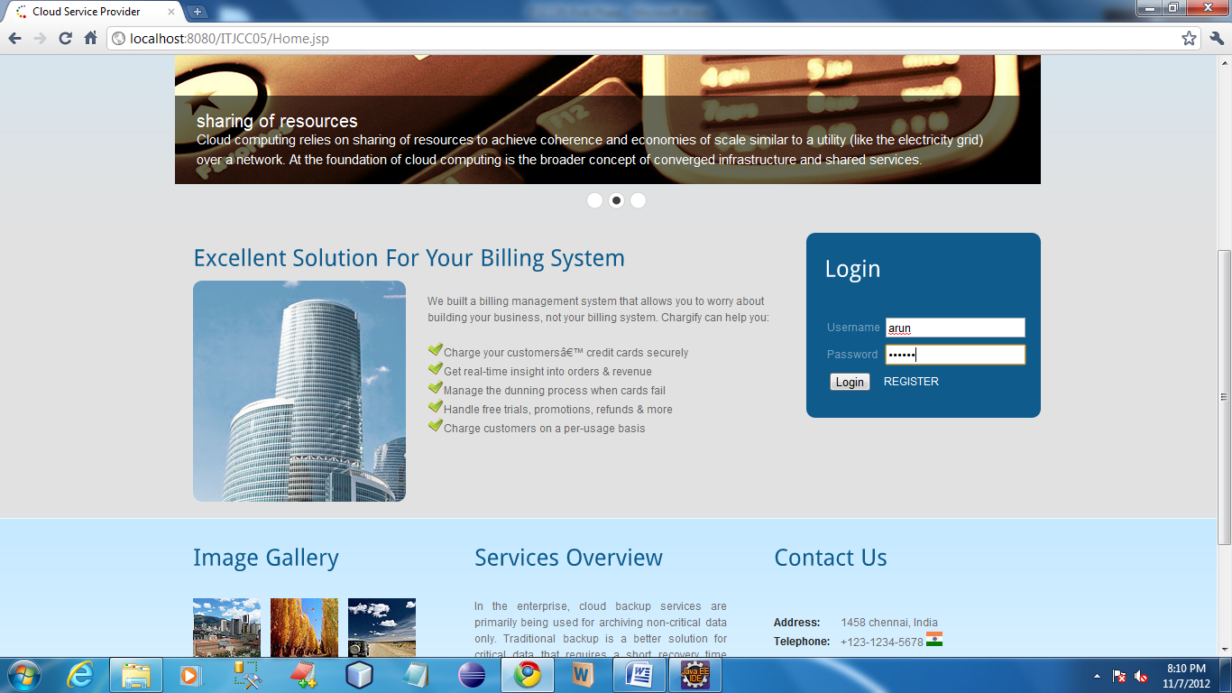

In this page user can log in by using the registered username and password. Once user authenticated by the server user homepage will open.

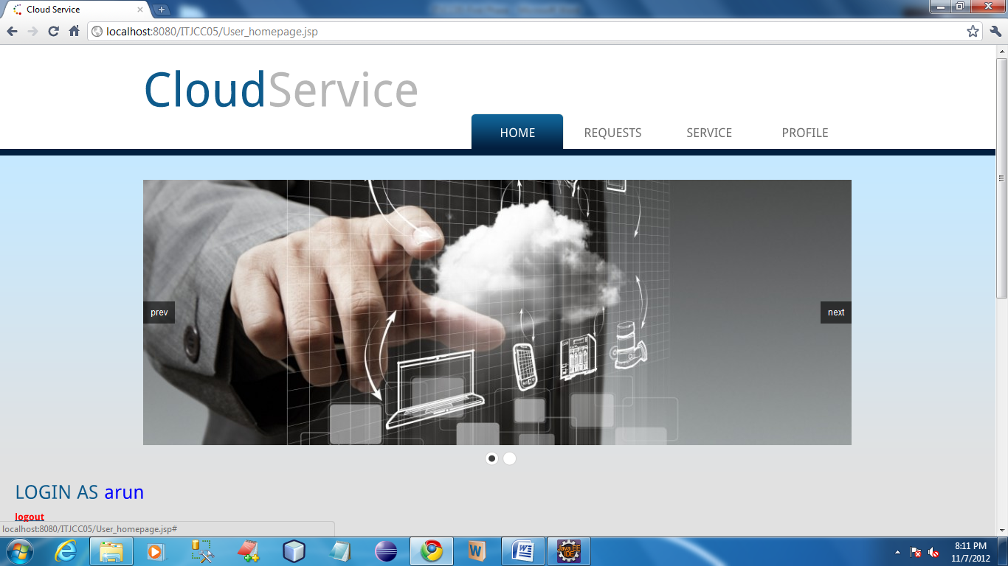

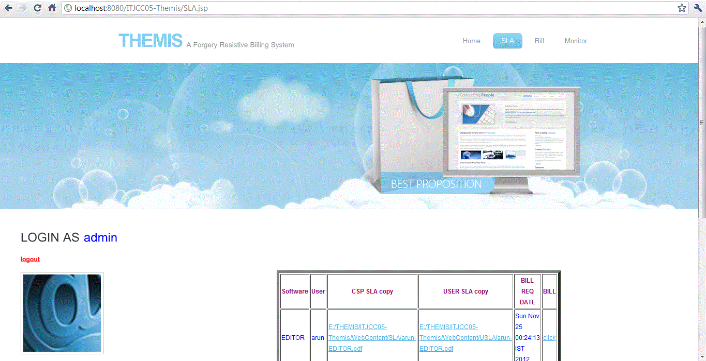

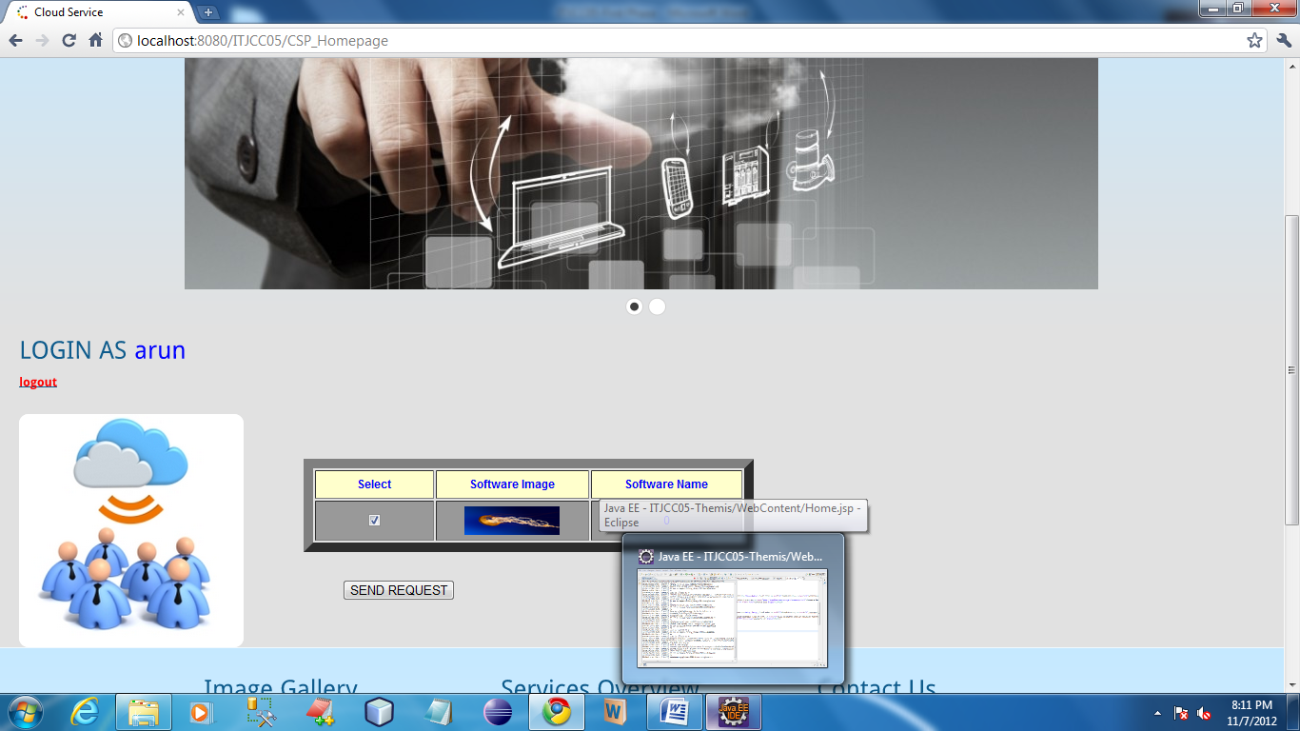

In this page user can view the services which was given by the CSP. In this page user can send the request to the CSP by selecting the available software.

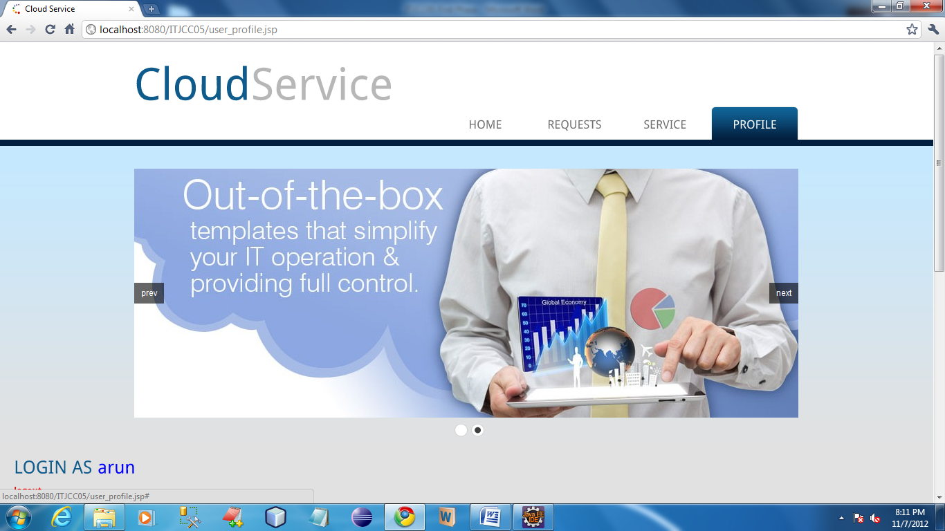

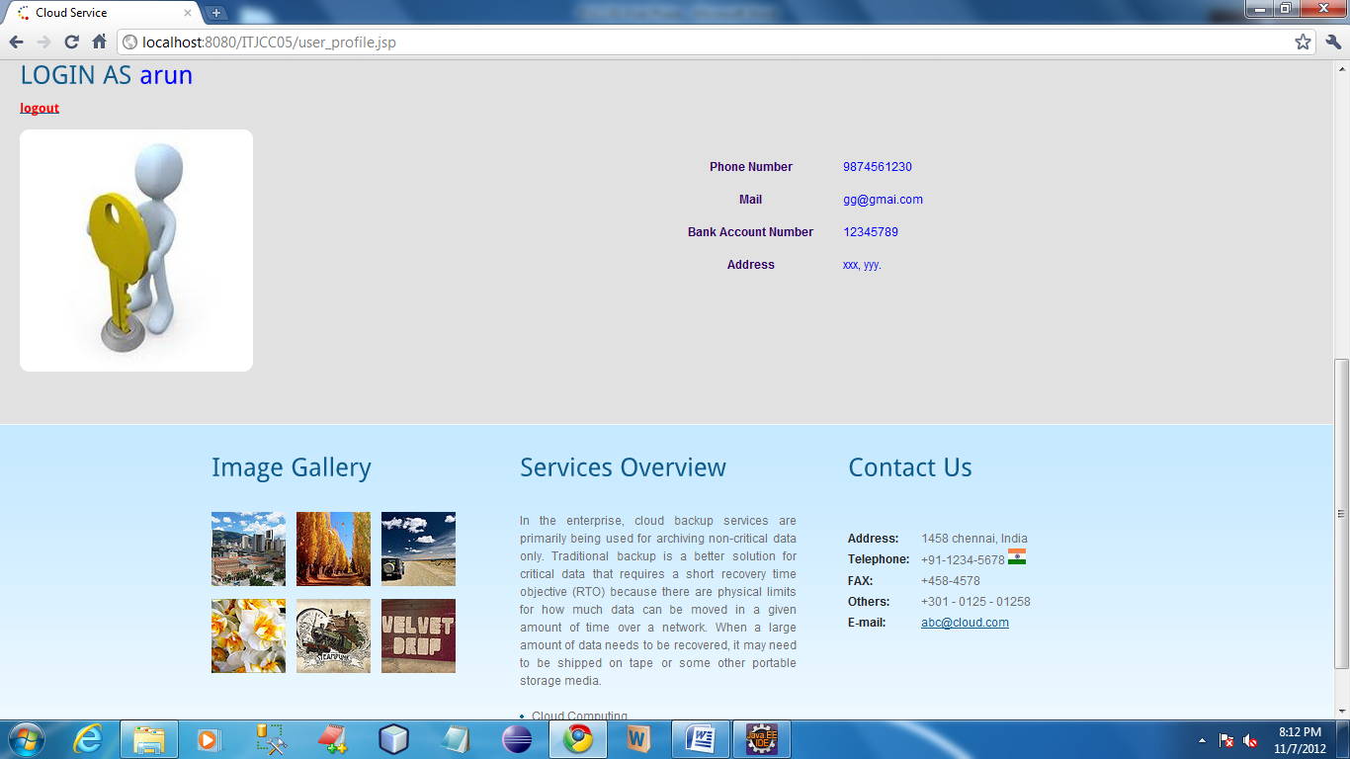

In this page user can view their profile details which was given at the time of registration.

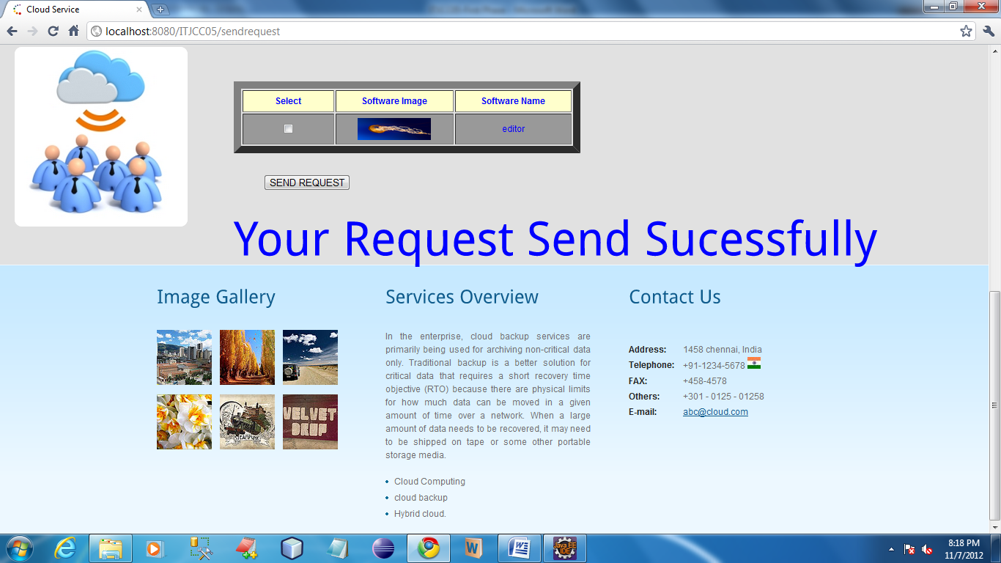

Once user send the request to the CSP, then the success message will be open.

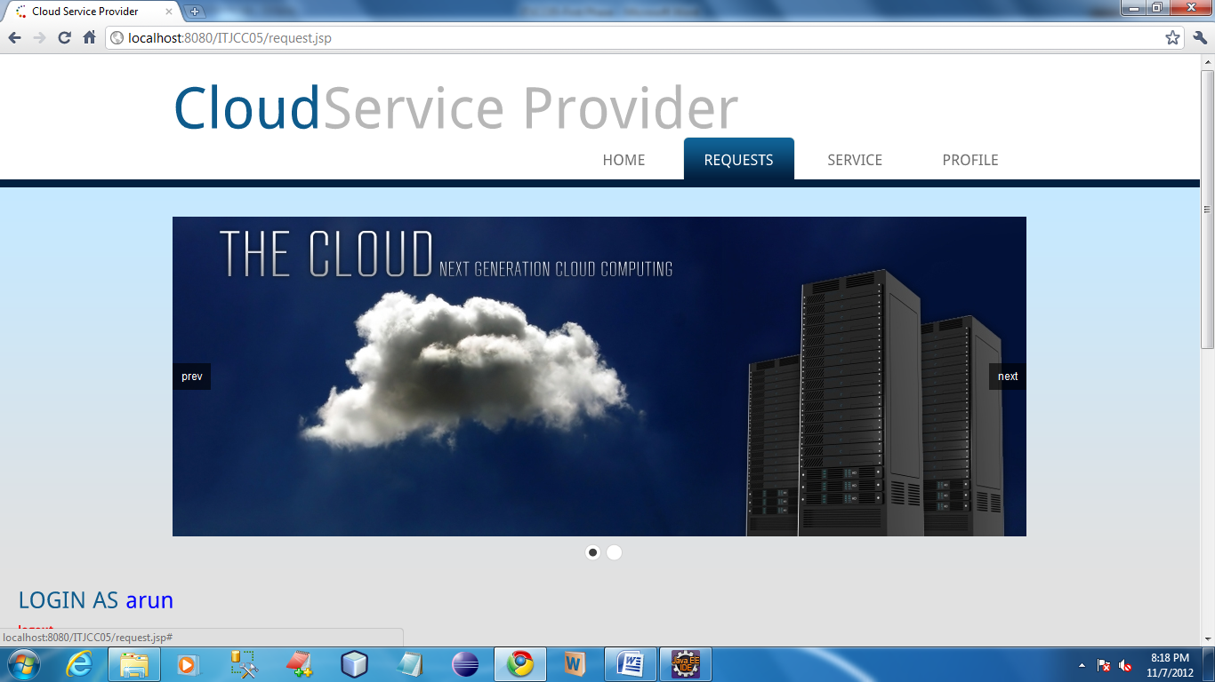

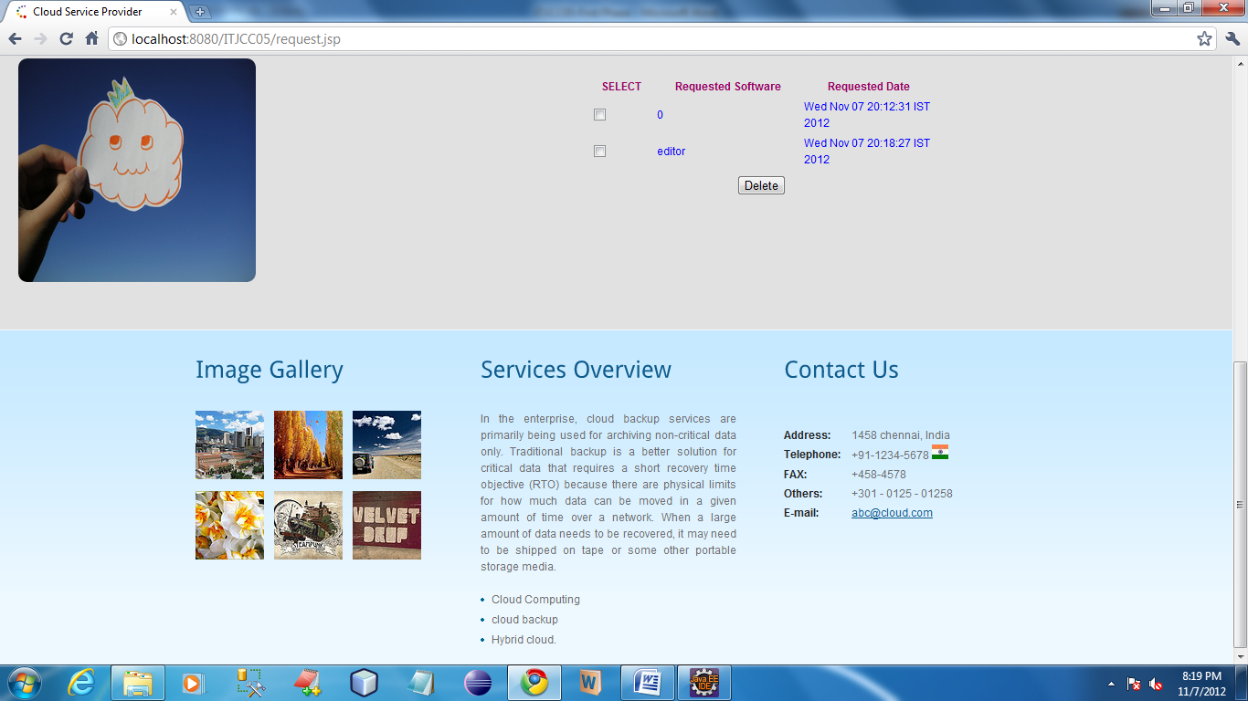

In this page user can view the log details of request which was send to the CSP.

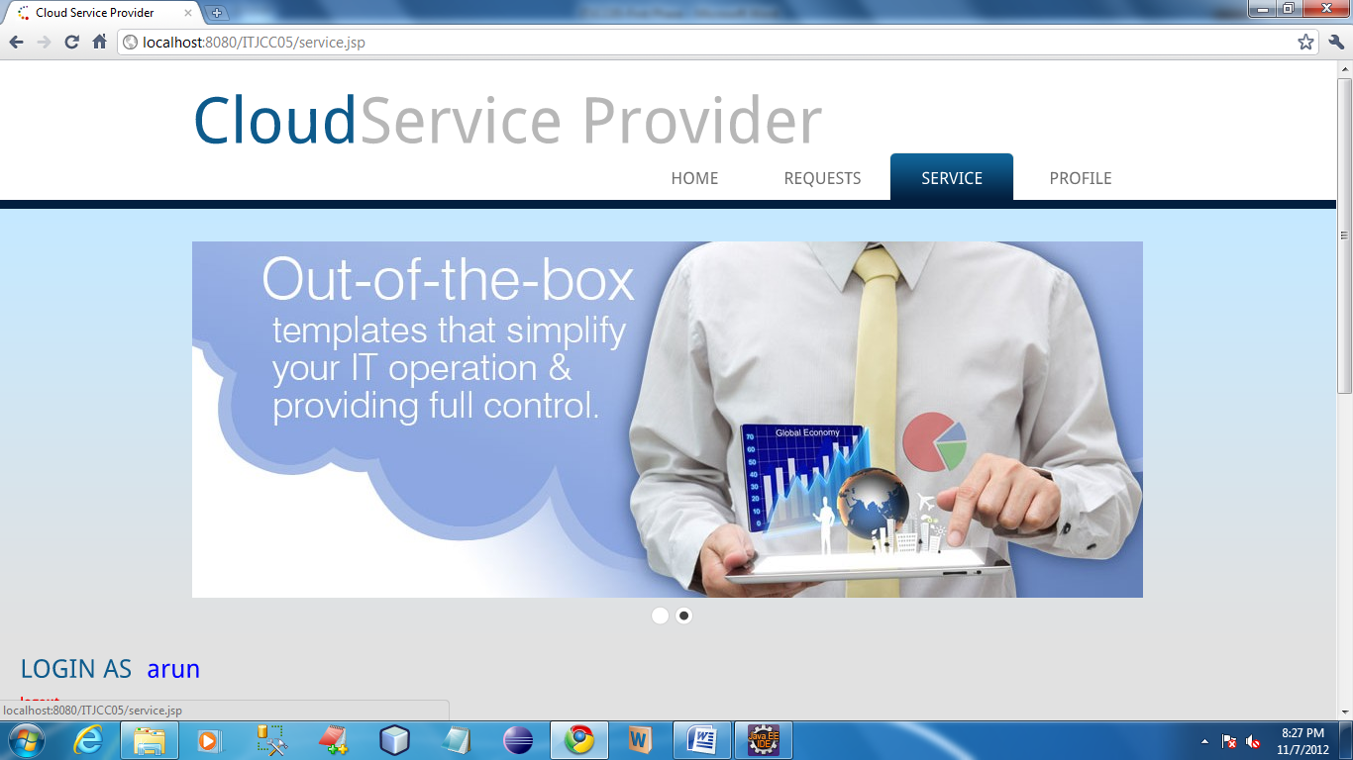

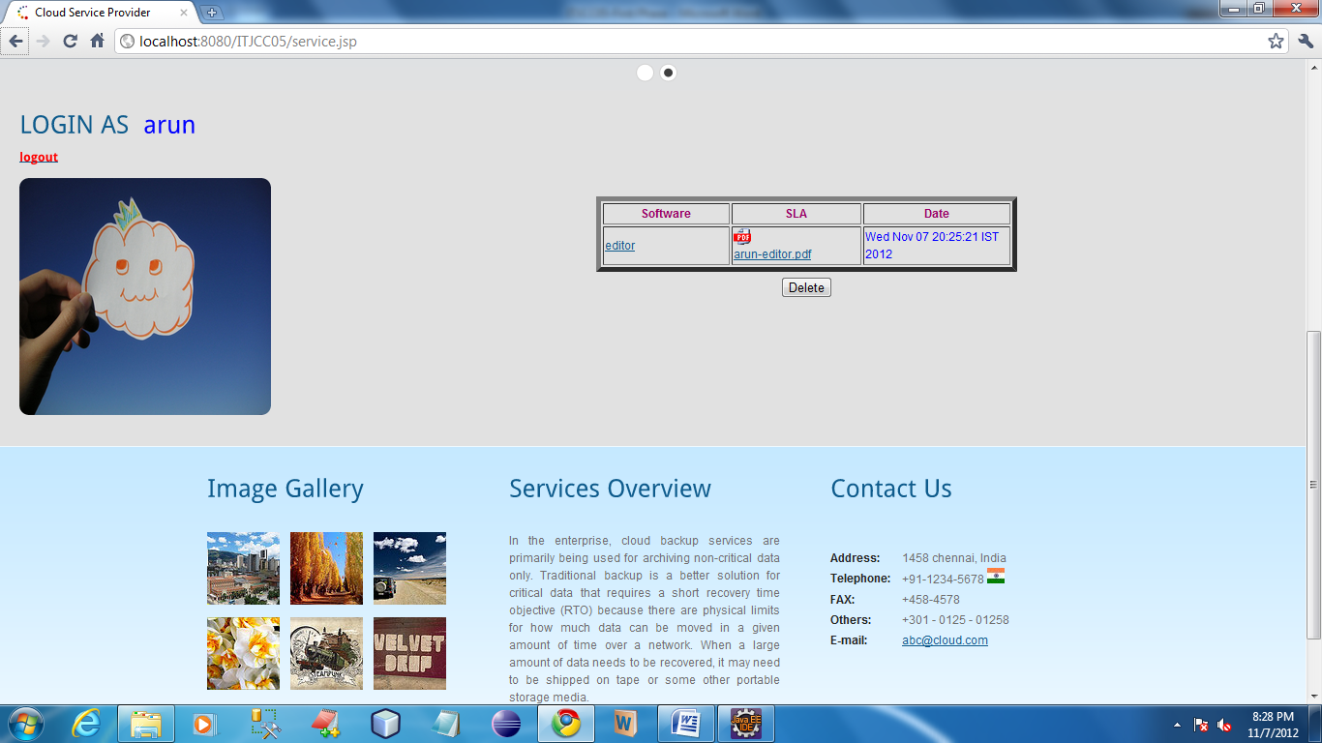

In this page user can download the SLA which was send by the CSP.

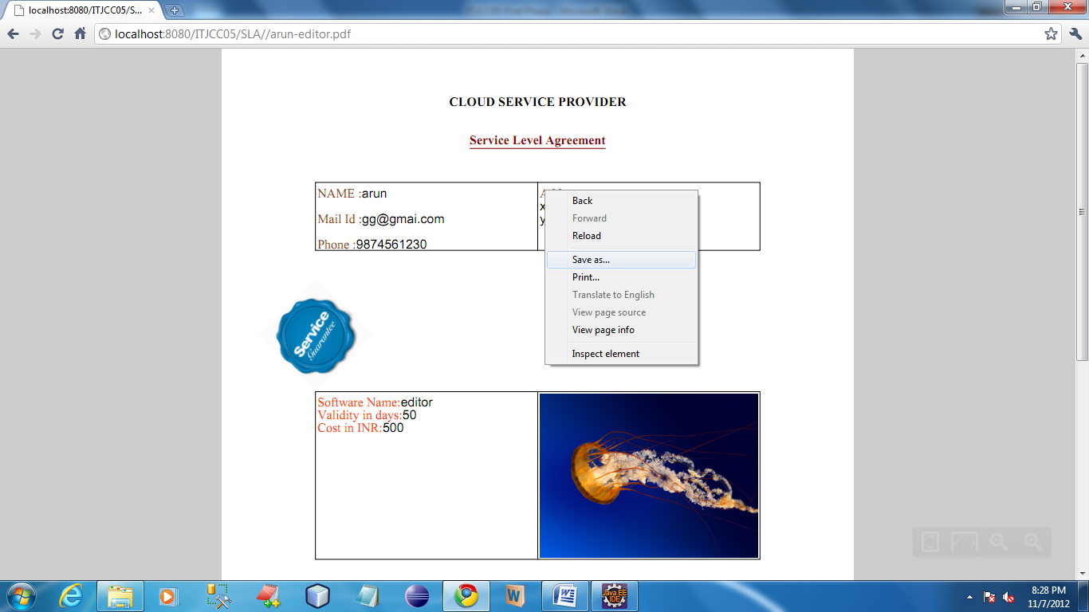

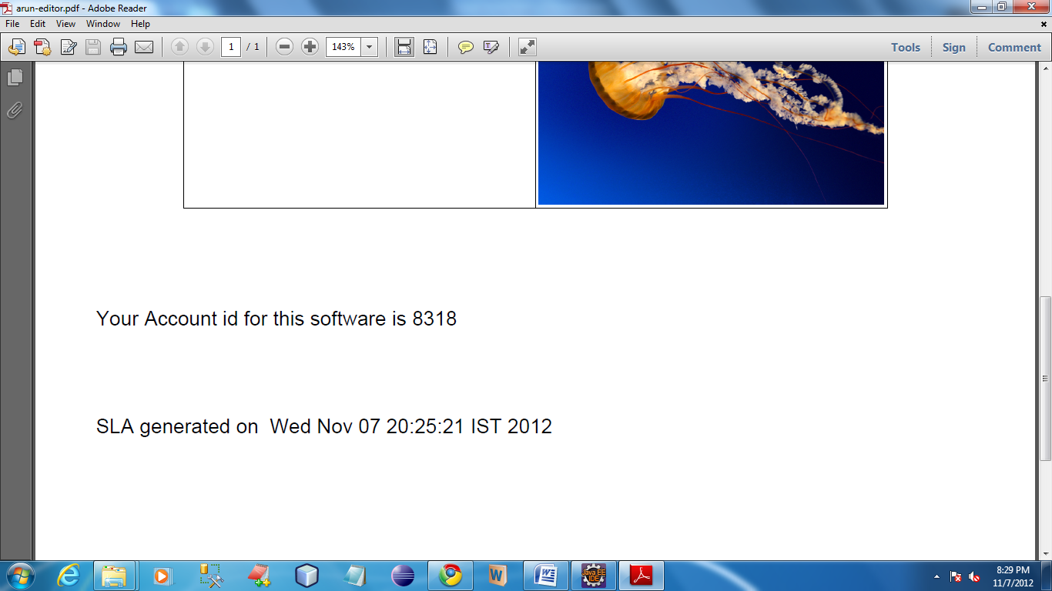

From the SLA user can get the onetime password. By using this password user can access the service.

In this page user should enter their account id for accessing the service.

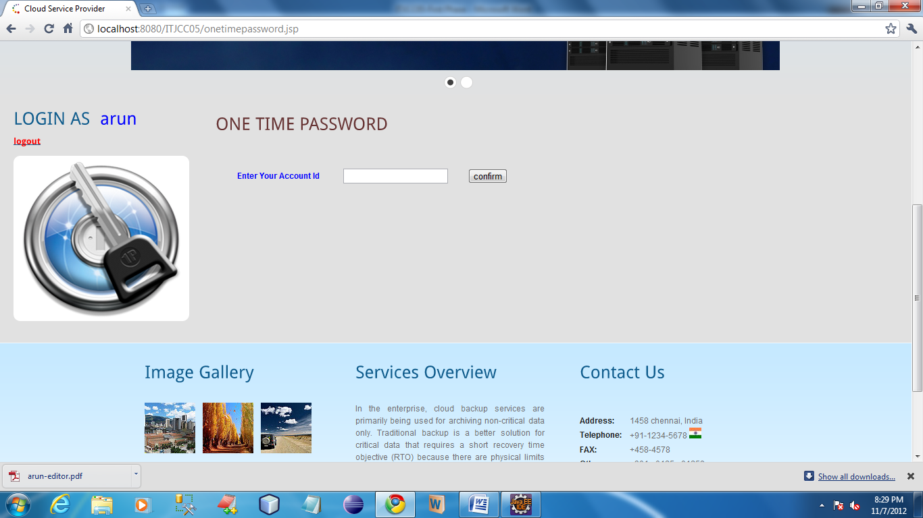

After entering onetime password it show service page as below

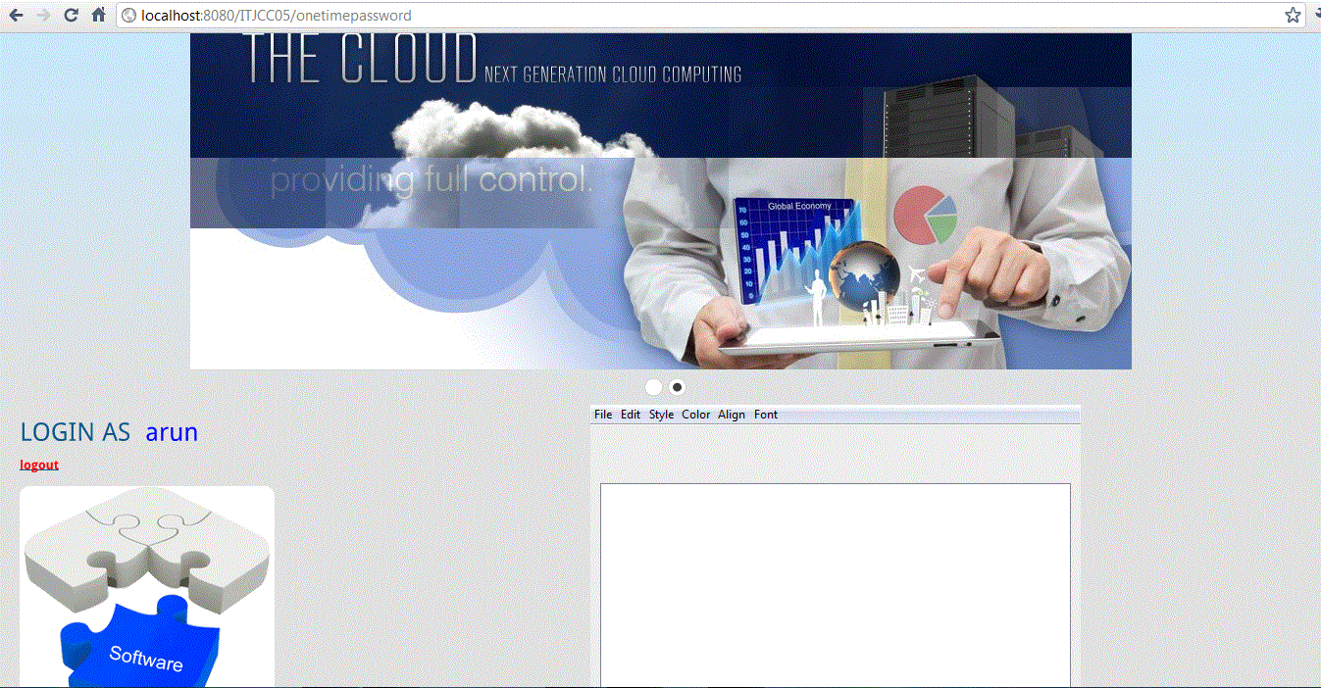

To send user SLA copy

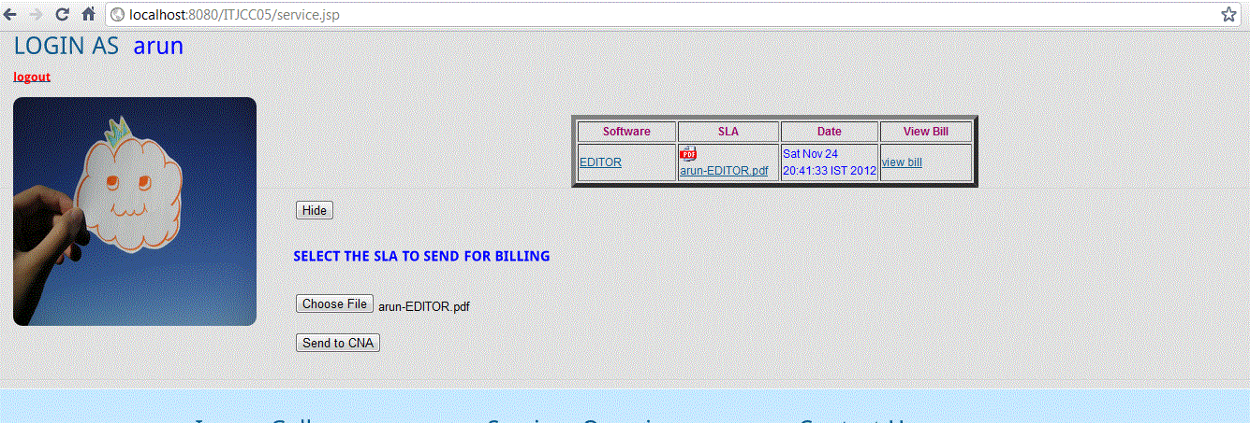

**Cloud Notary Authority (CNA)**

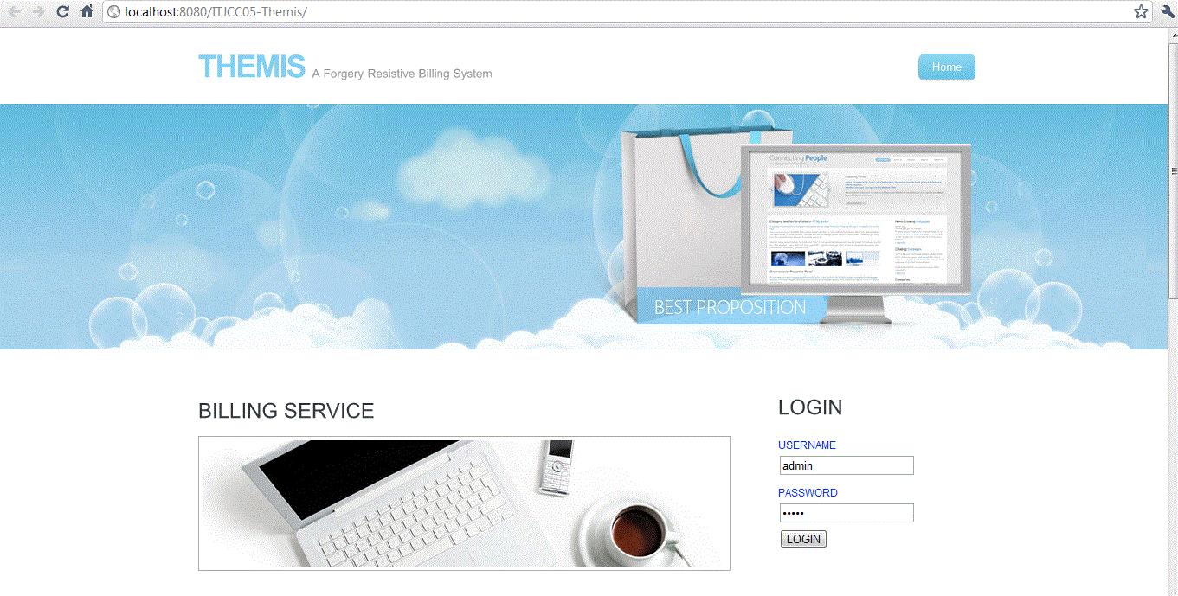

After logging from this page, it will show new form for receiving sla copies from CSP and user.



**Monitor**

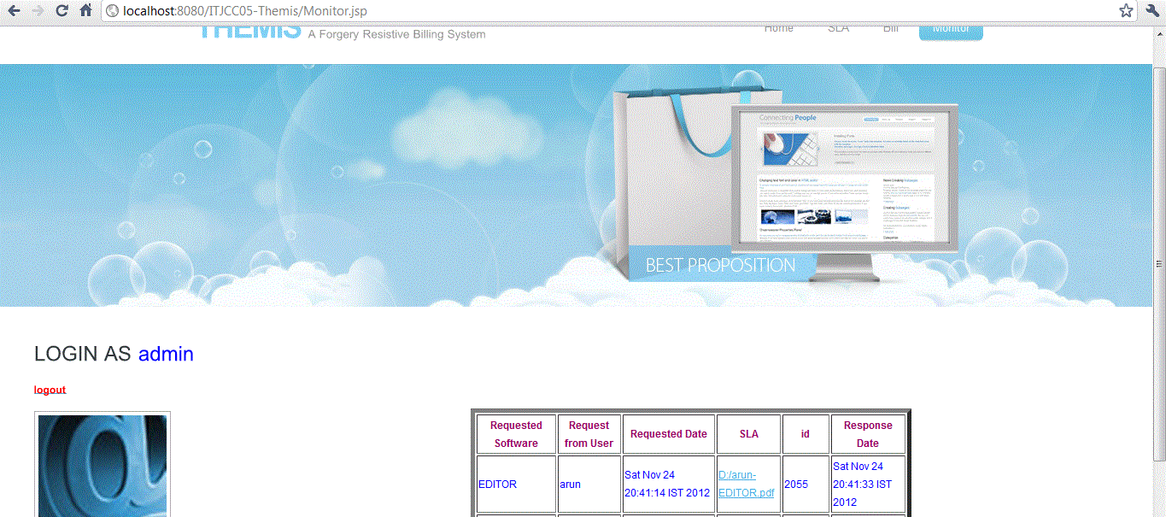

**Action against SLA violation**

If both SLA are identical then it produce the bill

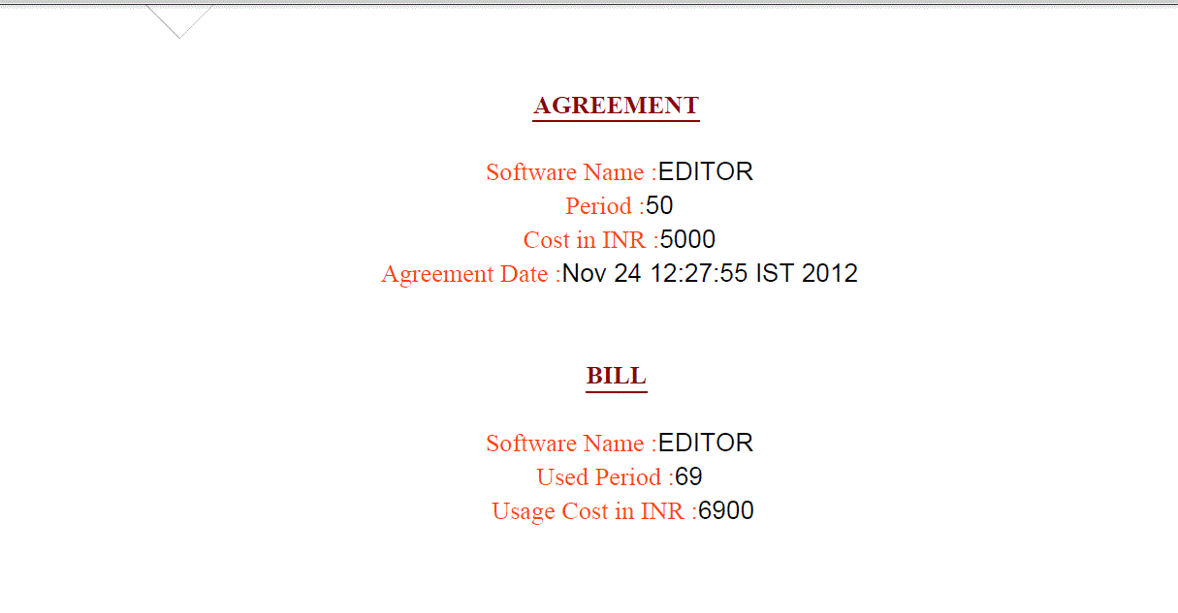

If any violation detected then it produce bill like below

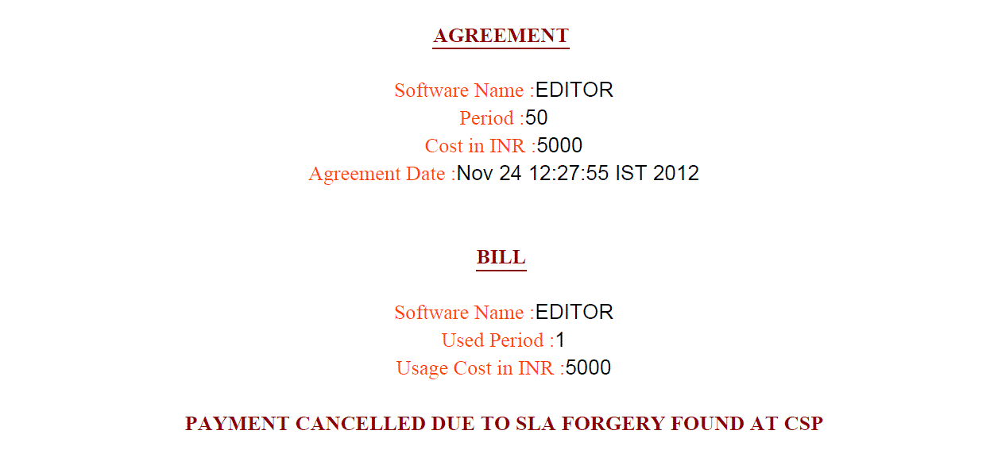

**CHAPTER 8**

**APPLICATIONS AND FUTURE ENHANCEMENT**

**8.1. GENERAL**

In this paper we propose the technique of THEMIS which leads to the new concept of SLA monitoring. For implementing this we are used some concepts which have real time applications.

**8.2. Application:**

**ePN Mobile iPhone**

This mobile phone have a application of transaction processing available at swiped rates through common smart phones, cell phones and PDA's. The ePN Mobile Credit Card, Check and Gift/Loyalty Application can prompt for invoice number, gratuity, other charges process the transaction real-time and show the transaction authorization number right on the phone display.

**VOSS Fulfillment Solution**

Specialty OSS vendors (Operational Support Systems) have developed end-to-end service orchestration solutions for service providers in the cloud communications space. VOSS Solutions is the leading OSS vendor in this public, cloud communications OSS space, with more tier-1 service provider customers than any other player.

**Absolute Performance SLA Monitoring**

Organizations have an increasing demand for business visibility.  As a business executive, it is vital to know the state of your business-critical and revenue critical applications at all times.  Knowing that your application is being managed to meet your business requirements is necessary to ensure 24x7 availability, transaction volume and performance of the application from the end-user perspective.  Absolute Performance provides the visibility through custom SLA monitoring, enabling executives to view real-time SLA compliance and reporting, consolidated into a cohesive, easy to use portal view.

**8.3. Future Enhancement**

In future, the deployment of THEMIS in the context of existing cloud computing services requires minimal modification to the CSPs, CNA and users if seeking to provide mutually verifiable billing transactions. Our next step is to consider the scalability and fault tolerance of THEMIS. This fault tolerance can be implemented by Banking service.

**CHAPTER 9**

**9.1 CONCLUSION**

THEMIS significantly reduces the billing transaction overhead. It provides a high securable and non obstructive billing system. Central Nodal Authority (CNA) generates the bill with binding information. It acts as forgery-resistive SLA measuring and logging mechanism. So even administrator of a cloud system cannot modify or falsify the data.

**9.2 REFERENCES**

1. L. C. M. C. Rob Byrom, Roney Cordenonsib, “Apel: An implementation of grid accounting using r-gma,” UK e-Science All Hands Conference, Nottingham, September 2005.

2. Frey, Tannenbaum, Livny, Foster, and Tuecke, “Condor-g: A computation management agent for multi-institutional grids,” Cluster Computing, vol. 5, pp. 237–246, 2002.

3. O.-K. Kwon, J. Hahm, S. Kim, and J. Lee, “Grasp: A grid resource allocation system based on ogsa,” in Proc. of the 13th IEEE Intl. Sympo. on High Performance Distributed Computing. IEEE

4. Computer Society, 2004, pp. 278–279. I. P. Release, “Tivoli: Usage and accounting manager,” IBM Press, 2009.

5. H. Rajan and M. Hosamani, “Tisa: Toward trustworthy services in a service-oriented architecture,” IEEE Transactions on Services Computing, vol. 1, pp. 201–213, 2008.

6. S. Meng, L. Liu, and T. Wang, “State monitoring in cloud datacenters,” IEEE Transactions on Knowledge and Data Engineering, vol. 23, pp. 1328–1344, 2011.

7. C. Olston and B. Reed, “Inspector gadget: a framework for custom monitoring and debugging of distributed dataflows,” in Proc. of the 2011 international conference on Management of data,

ser. SIGMOD ’11. ACM, 2011, pp. 1221–1224.

8. P. Leitner, A. Michlmayr, F. Rosenberg, and S. Dustdar, “Monitoring, prediction and prevention of sla violations in composite services,” in Proc. of the 2010 IEEE ICWS. IEEE Computer Society, 2010, pp. 369–376.

9. S. Pearson and B. Balacheff, Trusted computing platforms: TCPA technology in context, ser. HP Professional Series. Prentice Hall PTR, 2003.

10. I. P. Release, “White paper: Trusted execution technology, hardware-based technology for enhancing server platform security,” Intel Press, Tech. Rep., 2010.